Table of Contents

Virtualization & Cloud 1

Virtual Routing& Forwarding (VRF) 12

Wireless 15

Wireless Fundamentals 15

Wireless Architecture 27

Wireless Security 37

Network Automation 44

Network Automation 44

AI & Machine Learning 49

JSON, XML, YAML 53

REST APIs 55

REST API Authentication 60

Software Defined Networking 65

Ansible, Puppet, Chef 70

Terraform 76

# Virtualization & Cloud

Things covered

* Intro to Virtualization
  + Virtual servers
  + Virtual networks
* Intro to cloud computing
  + Essential characteristics
  + Service Models
  + Deployment Models
* Connecting to public clouds

**Server Hardware**

* Although Cisco is more known for their networking devices, they also have hardware servers such as UCS (Unified Computing Systems)
* The larger vendors of hardware servers include DELL EMC, HPE etc

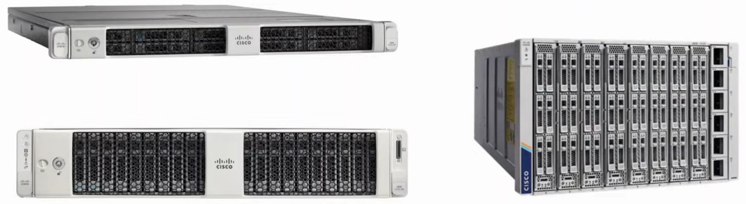

**Virtualization**

**Servers before Virtualization**

* Before virtualization, there was a 1-to-1 relationship btw a physical server and an OS
* In that OS, apps providing services such as web server, email server, etc would run
* 1 physical server would be used for each service
  + E.g. 1 physical server for email, 1 for web server, etc
  + Prevents a problem from a single app from affecting all other apps
* This is inefficient
  + Each physical server is expensive and takes up space, power, etc
  + The resources on each physical server (CPU, RAM, Storage, NIC) are typically under-used

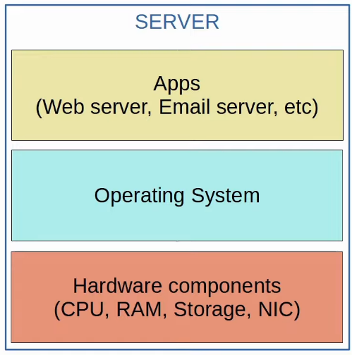

**Type 1 Hypervisor**

* Virtualization allows us to break the 1-to-1 relationship of hardware to OS, allowing multiple OS's to run on a single physical server
* Each instance is called a VM (Virtual Machine)
* A hypervisor is used to manage and allocate the hardware resources (CPU, RAM, etc) to each VM
* Another name for a hypervisor is VMM (Virtual Machine Monitor)
* The type of hypervisor which runs directly on top of the hardware is called a Type 1 hypervisor
  + E.g. VMware ESXi, Microsoft Hyper-V, etc
* Type 1 hypervisor are also called bare-metal hypervisors because they run directly on hardware (metal)
  + Another term is native hypervisor
* This is the type used in data center environments

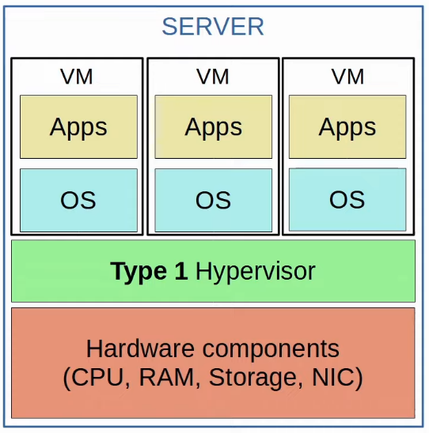

**Type 2 Hypervisor**

* Type 2 hypervisors run as a program on an OS like a regular computer program
  + E.g. VMware workstation, Oracle VirtualBox, etc
* The OS running directly on the hardware is called the Host OS, and the OS running in a VM is called a Guest OS
* Another name is hosted hypervisor
* Although Type 2 hypervisors are rarely used in data center environments, they are common on personal-use devices
  + E.g. a Mac/Linux user needs to run an app that is only available in Windows

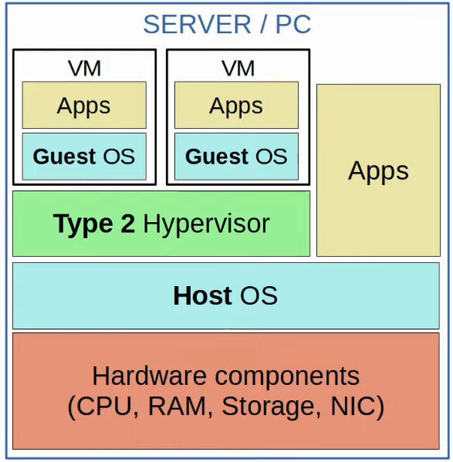

**Why Virtualization?**

* Partitioning
  + Run multiple OS on 1 physical machine
  + Divide system resources btw VMs
* Isolation
  + Provide fault and security isolation at the hardware level
  + Preserve performance with advanced resource controls
* Encapsulation
  + Save the entire state of a VM to files
  + Move and copy VMs as easily as moving and copying files
* Hardware Independence
  + Provision or migrate any VM to any physical server

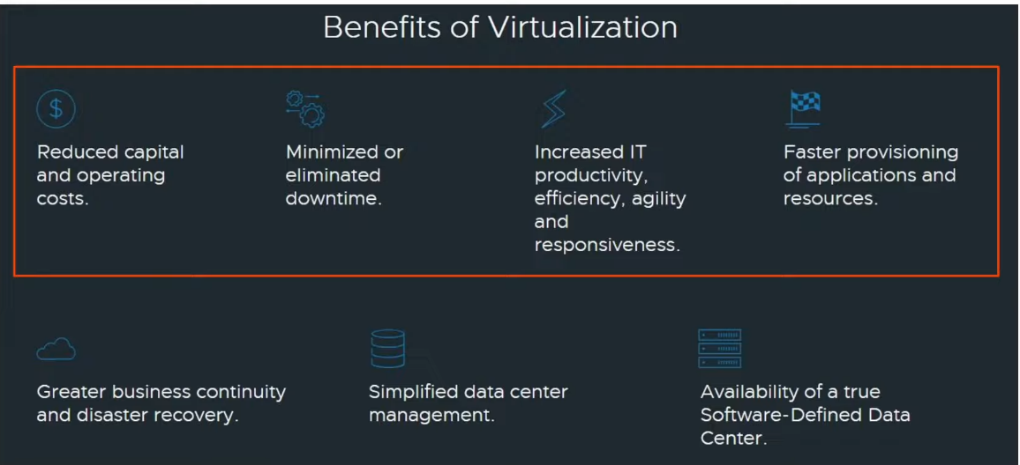

**Connecting VMs to the Network**

* VMs are connected to each other and the external network via a virtual switch running on the hypervisor
* Just like a regular physical switch, the vSwitch's interfaces can operate as access/trunk ports and use VLANs to separate VLANs at Layer 2
* Interfaces on the vSwitch connect to the physical NIC (or NICs) of the server to communicate with the external network
* Virtual Port Channel (VPC) can be formed to connect the NICs with the switches for redundancy

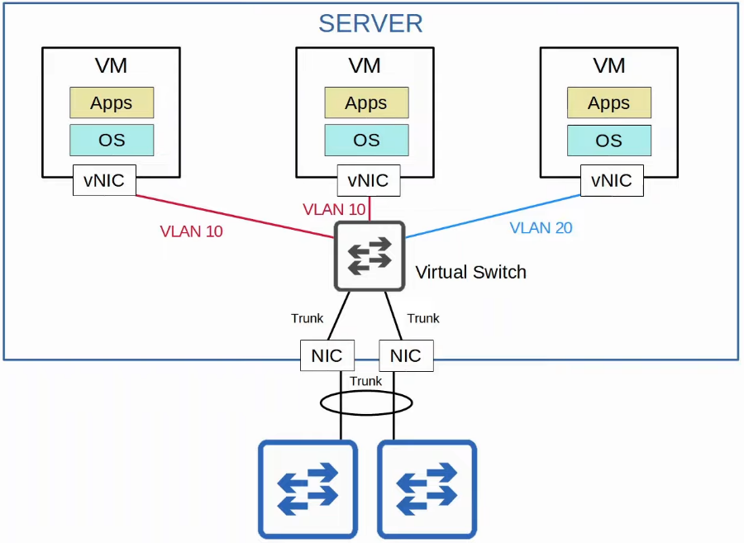

**Cloud Services**

* Traditional IT infrastructure deployments were some of the following combination
  + On-Premise
    - All servers, network devices, and other infrastructure are located on company property
    - All equipment is purchased and owned by the company
    - The company is responsible for necessary power, space and cooling
  + Colocation
    - Data centers that rent out space for customers to put their infrastructure (e.g. servers etc)
    - The data centers provides the space, power and cooling
    - The servers are still the responsibility of end customer, although they are not located on the customer's premise
* Cloud services provide an alternative that is hugely popular, and is continuing to grow
* Most people associate 'cloud' with public cloud providers such as AWS
  + Although it is the most common use of cloud services, it's not the only one

* The American NIST (National Institute of Standards and Technology) defined cloud computing in SP (Special Publication) 800-145
* "Cloud computing is a model for enabling ubiquitous, convenient, on-demand network access to a shared pool of configurable computing resources (e.g., networks, servers, storage, applications, and services) that can be rapidly provisioned and released with minimal management effort or service provider interaction. This cloud model is composed of five essential characteristics, three service models, and four deployment models."
* The main things outlined
  + 5 essential characteristics
  + 3 service models
  + 4 deployment models

**5 Essential Characteristics**

* **On-demand self-service**
  + "A customer can unilaterally provision computing capabilities, such as server time, and network storage, as needed automatically w/o requiring human interaction with each service provider"
  + The customer is able to use the service (or stop the service) freely (via web portal) w/o direct communication with the service provider
* **Broad network access**
  + "Capabilities are available over the network and accessed through standard mechanisms that promote use by heterogeneous thin or thick client platforms (e.g. mobile phones, tablets, laptops, and workstations)
  + The service is available through standard network connections (e.g. Internet, private WAN connections) and can be accessed through many kind of devices
* **Resource pooling**
  + A pool of resources is provided by the service provider, and when a customer requests a service (e.g. creates a new VM), the resources to fulfil that request are allocated from the shared pool
* **Rapid elasticity**
  + Customers can quickly expand the services they use in the cloud (e.g. add new VMs, expand storage, etc) from a pool of resources that appears to be infinite
  + Likewise, they can quickly reduce their services when not needed
* **Measured service**
  + The cloud service provider measures the customer's usage of cloud resources, and the customer can measure their own use as well
  + Customers are charged based on usage

**3 Service Models**

* In cloud computing, everything is provided on a 'service' model
* E.g. Rather than buying a physical server, mounting it on a rack, installing the hypervisor, creating VMs, etc, the service provider offers all of this as a service
* There are a variety of services referred to as '__ as a service' or '__aaS'
* The 3 service models are
  + **Software as a Service (SaaS)**
    - The capability provided to the consumer is to use the provider's applications running on cloud services
    - Microsoft Office 365 is a popular example of SaaS
  + **Platform as a Service (PaaS)**
    - The capability provided to the consumer is to deploy onto the cloud infrastructure consumer-created or acquired applications using programming languages, libraries, services, and tools supported by the provider
    - Service provider provides a platform for developers to run applications
    - E.g. AWS Lambda, Google App Engine
  + **Infrastructure as a Service (IaaS)**
    - Capability provided is to provision processing, storage, networks, and other fundamental computing resources where the consumer is able to deploy and run arbitrary software, which can include OS and applications
    - Consumer cannot control underlying cloud infrastructure, but can control OS, storage and deployed applications
    - E.g. EC2 and Google Compute Engine

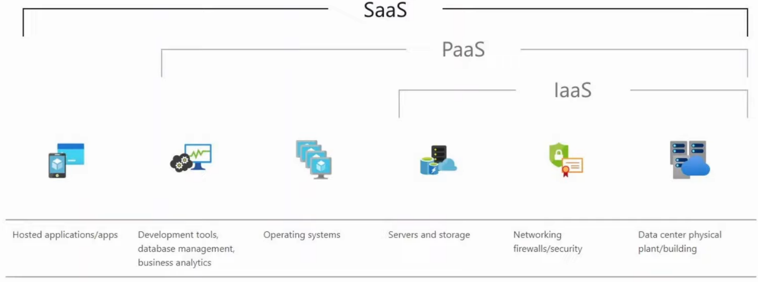

**4 Deployment Models**

* Most people assume 'cloud' means public providers such as AWS, Azure, and GCP
* Although Public cloud is the most common deployment model, it's not the only one
* 4 deployment models
  + **Private cloud**
    - Generally used by large enterprises only
    - Although private, may be owned by a 3rd party
      * E.g. AWS provides private cloud services to American DoD
    - May be on/off premises
    - Same kind of services as in public clouds are offered (SaaS, PaaS, IaaS), but the infrastructure is reserved for a single organization
  + **Community cloud**
    - Least common
    - Same as public, but a group instead of 1 organization
  + **Public cloud**
    - Most common
    - Can be used by the public
  + **Hybrid cloud**
    - A combination of the 3 deployment types
    - E.g. a private cloud which can offload to a public cloud when necessary

**Benefits of Cloud**

* **Cost**
  + Capital Expenses of buying hardware, setting up data centers, etc are reduced or eliminated
* **Global scale**
  + Cloud services can scale globally at a rapid pace
  + Services can be set up and offered to customers from a geographic location close to them
* **Speed/Agility**
  + Services are provided on demand, and vast amounts of resources can be provisioned within minutes
* **Productivity**
  + Cloud services remove the need for many time-consuming tasks such as procuring physical servers, racking them, cabling, installing and updating OS, etc
* **Reliability**
  + Backups in the cloud are very easy to perform
  + Data can be mirrored at multiple sites in different geographic locations to support disaster recovery

**Connecting to Cloud Resources**

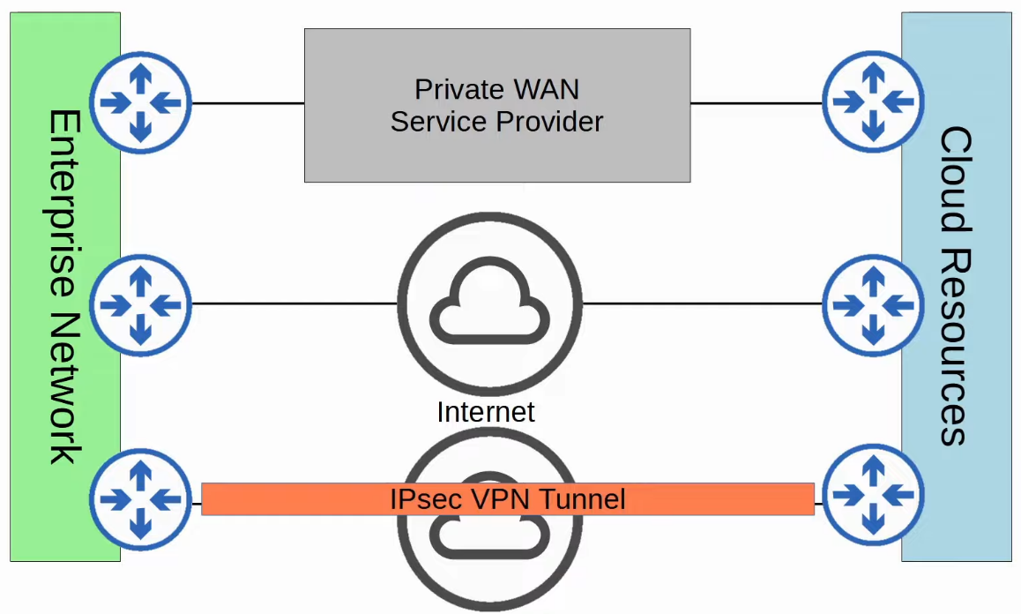

Virtualization: Containers

Things covered

* Review of VMs
* Containers
* VM vs Container

**Virtual Machines**

W/o Virtualization



With Virtualization

* VMs allow multiple OS's to run on a single physical server.
* A Hypervisor is used to manage and allocate hardware resources to each VM.
  + Type 1 Hypervisors (aka Native or Bare-metal) run directly on top of hardware.
  + Type 2 Hypervisors (aka Hosted) run on top of a Host OS (ie. Windows).
* Bins/Libs are the software libraries/services needed by the Apps running in each VM.
* A VM allows its app/apps to run in an isolated environment, separate from the apps in other VMs.
* VMS are easy to create, delete, move, etc.
  + A VM can be easily saved and moved between different physical servers.

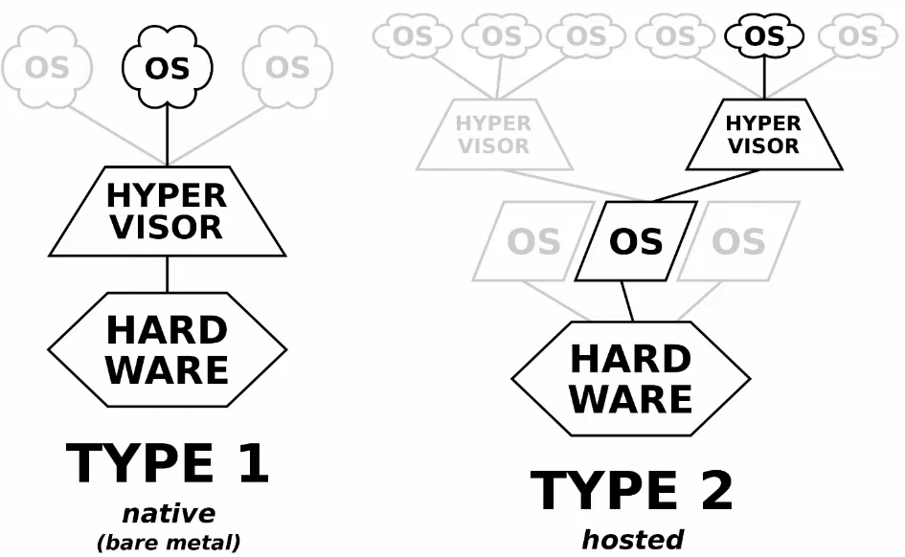

**Containers**

* Containers are software packages that contain an App and all dependencies (Bins/Libs in the diagram) for the contained App to run.
  + Multiple Apps can be run in a single container, but this is not how containers are usually used
* Containers run on a Container Engine (i.e. Docker Engine)
  + The container engine is run on a host OS (usually Linux)
* Containers are lightweight (small in size) and include only the dependencies required to run the specific App
* A Container Orchestrator is a software platform for automating the deployment, management, scaling etc. of containers
  + Kubernetes (originally designed by Google) is the most popular container orchestrator
  + Docker Swarm is Docker's container orchestration tool.
* In small numbers manual operation is possible, but large-scale systems (ie. with Microservices) can require thousands of containers
* Microservice Architecture is an approach to software architecture that divides a larger solution into smaller parts (microservices).
  + Those microservices all run in containers that can be orchestrated by Kubernetes (or another platform).

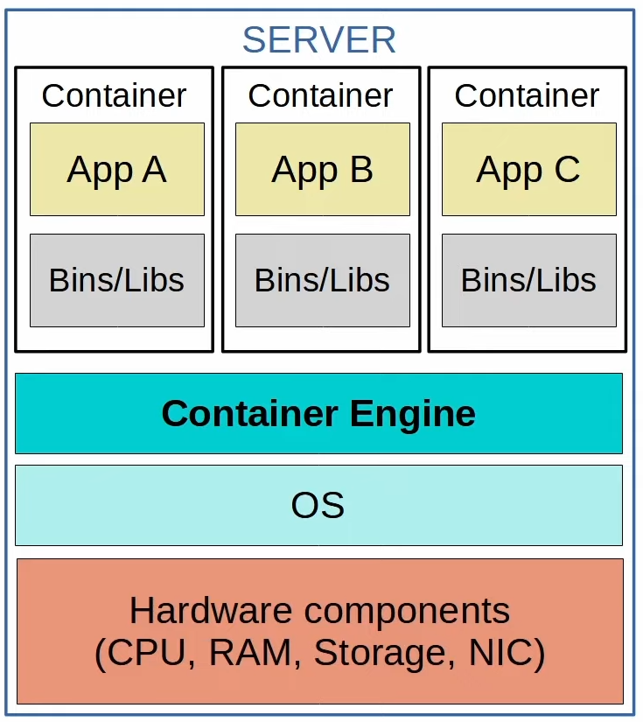

**VM vs Container**

* Boot up time
  + VM: take minutes as each VM run its own OS
  + Containers: in milliseconds
* Space
  + VM: use more disk space (GB)
  + Container: very little disk space (MB)
* Resources
  + VM: use more CPU/RAM resources (each VM run its own OS)
  + Container: use fewer CPU/RAM (shared OS)
* Portability
  + VM: portable and can move btw physical systems running the same hypervisor
  + Container: more portable, they are smaller, faster to boot up, and Docker containers can be run on nearly any container service
* Reliability
  + VM: more isolated as each VM runs its own OS
  + Container: less isolated because they all run on the same OS; if the OS crash, all containers running on it are affected

# Virtual Routing& Forwarding (VRF)

Things covered

* Intro to VRF
* Config

**VRF (Virtual Routing & Forwarding)**

* VRF is used to divide a single router into multiple virtual routers
  + Similar to how VLANs are used to divide a single switch (LAN) into multiple virtual switches (VLAN)
* Does this by allowing a router to build multiple separate routing tables
  + Interfaces (Layer 3 only) and routes are configured to be in specific VRF (aka VRF instance)
  + Router interfaces, SVIs and routed ports on multilayer switches can be configured in a VRF
* Traffic in 1 VRF cannot be forwarded out of an interface in another VRF
  + As an exception, VRF leaking can be configured to allow traffic to pass btw VRFs
* VRF is commonly used to facilitate MLPS
  + The kind of VRF we are talking about is VRF-lite (VRF w/o MPLS)
* VRF is commonly used by service providers to allow 1 device to carry traffic from multiple customers
  + Each customer's traffic is isolated from the others
  + Customer IP addresses can overlap w/o issues

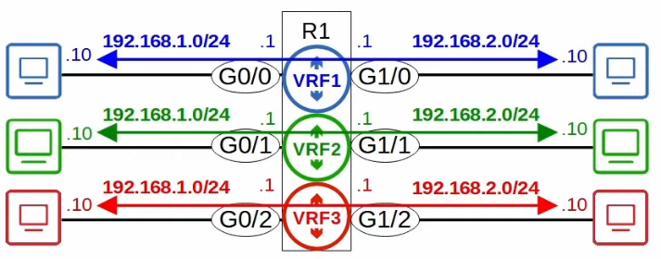

**Config**

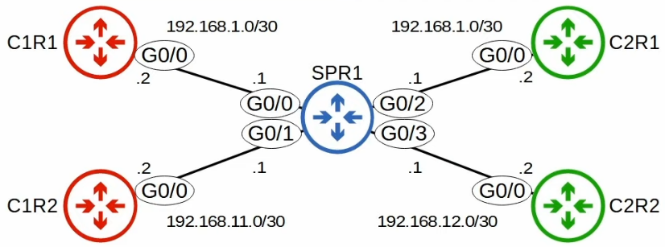

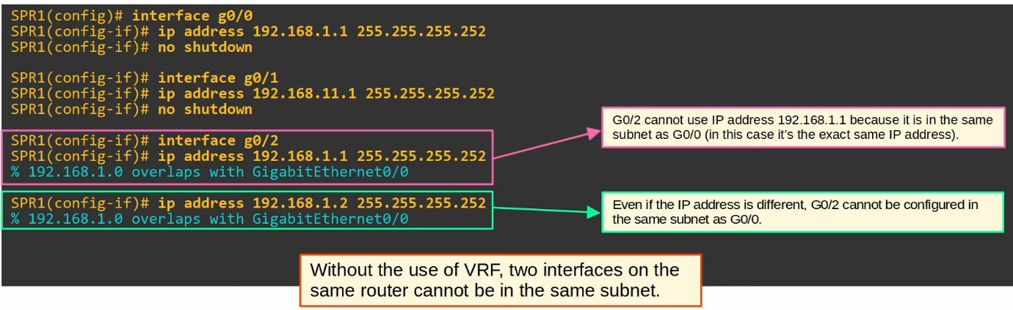

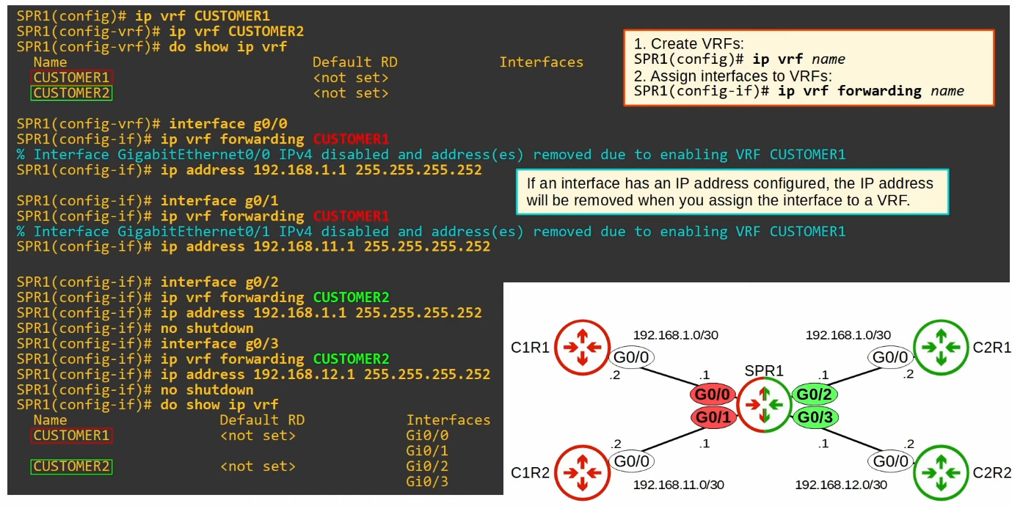

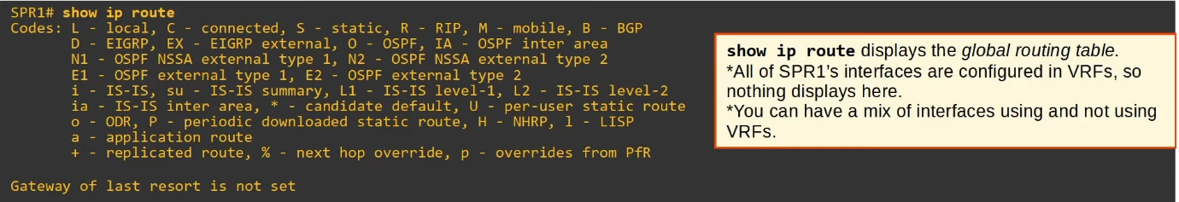

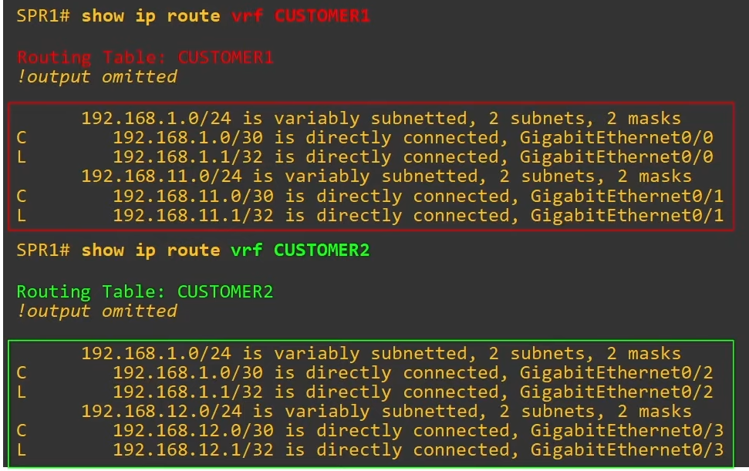

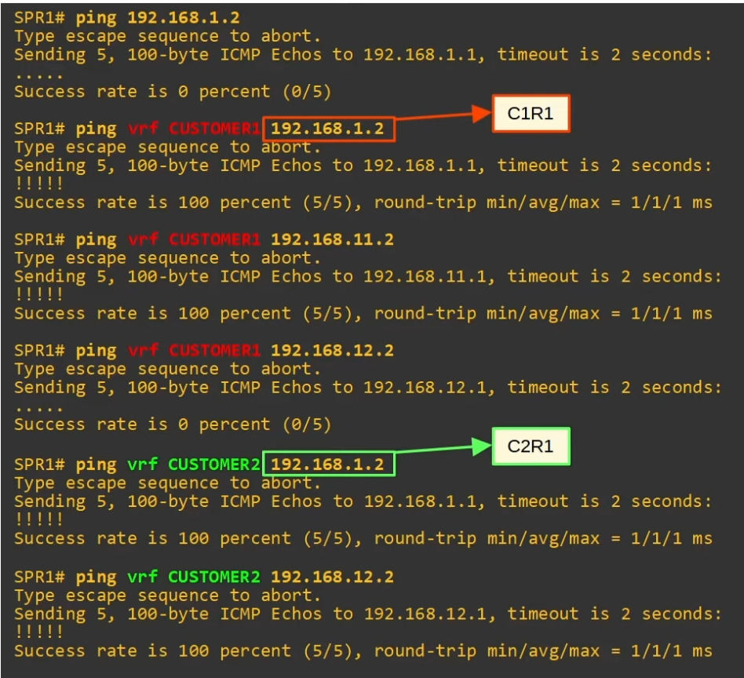

# Wireless

## Wireless Fundamentals

 Things covered

* Radio Frequency (RF)
* Wi-fi standards
* Wireless LAN Fundamentals

Wireless Networks

* The standards used for wireless LAN is defined in IEEE 802.11
* The term 'Wi-Fi' is a trademark of the 'Wi-Fi Alliance', not directly connected to IEEE
  + They test and certify equipment for 802.11 standards compliance interoperability with other devices
  + However, wifi has become the common term to refer to 802.11 wireless LAN

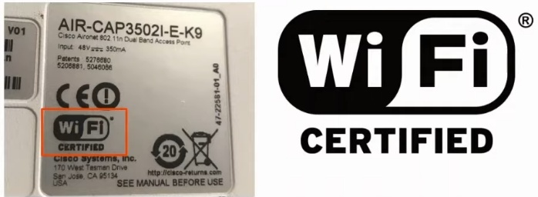

* Wireless networks have some issues that needs to be dealt with
  1. All devices within range receive all frames, like devices connected to an Ethernet hub
     + Privacy of data within the LAN is a greater concern
     + CSMA/CA (Carrier Sense Multiple Access with Collision Avoidance) is used to facilitate half duplex communications
       - CSMA/CD used in wired networks to detect and recover from collisions
       - CSMA/CA used in wireless networks to avoid collisions
       - When using CSMA/CA , a device will wait for other devices to stop transmitting before it transmits data itself

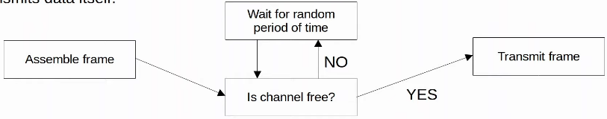

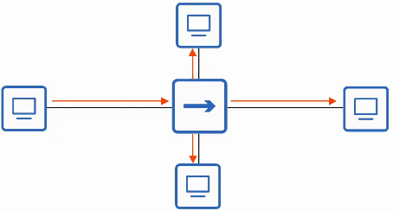

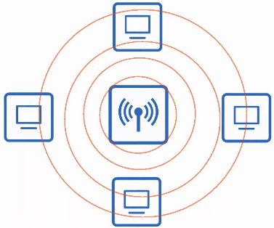

1. Wireless communications are regulated by various international and national bodies
   * Covered in IEEE 802.11

1. Wireless signal coverage area must be considered
   * Signal range
   * Signal absorption, reflection, refraction, diffraction, and scattering
     + Signal Absorption
       - Happens when a wireless signal passes through a material and is converted into heat, weakening the original signal

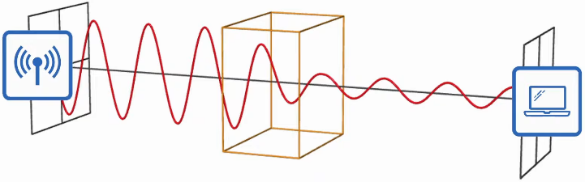

* Signal Reflection
  + Happens when a signal bounces off a material, e.g. metal
  + This is why Wi-Fi reception is usually poor in elevators, the signal bounce off the metal and very little penetrates into the elevator

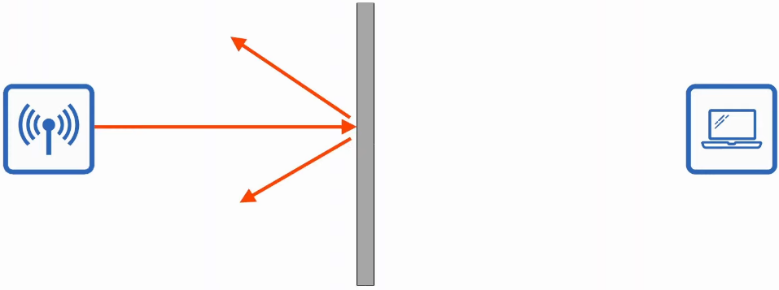

* Signal Refraction
  + Happens when a wave is bent when entering a medium where the signal travels in a different speed
  + E.g. Glass and water can refract waves

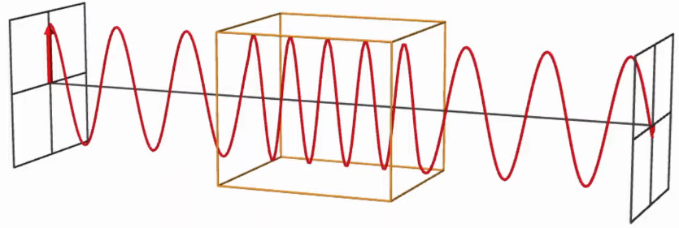

* Signal Diffraction
  + Happens when a wave encounters an obstacle and travels around it
  + This can result in blind spots behind the obstacle

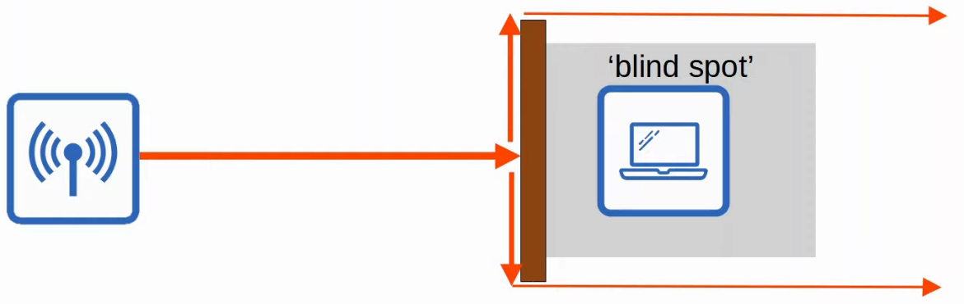

* Signal Scattering
  + Happens when a material causes a signal to scatter in all directions
  + E.g. dust, smog, uneven surfaces can cause scattering

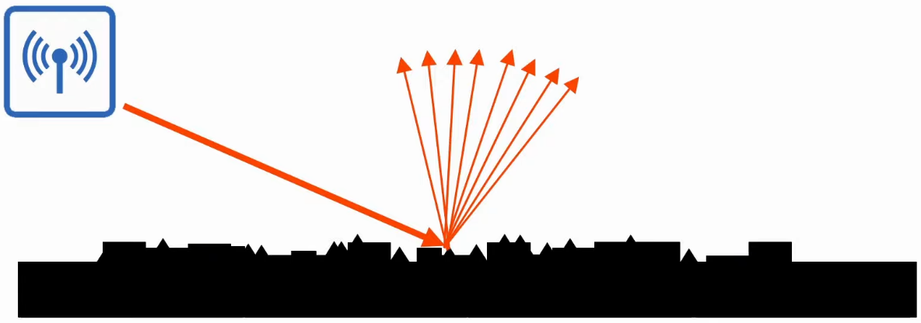

1. Other devices using the same channels can cause interference
   * E.g. a wireless LAN in your neighbour's house/apartment

Radio Frequency (RF)

* To send wireless signals, the sender applies an alternating current to an antenna
  + This creates EM fields which propagate out as waves
* EM waves can be measured in multiple ways, e.g. amplitude and frequency
  + Amplitude is the max strength of the electric and magnetic fields
  + Frequency measures the number of up/down cycles per unit time
    - Hertz (Hz)
    - Period = time of 1 cycle
* Visible frequency: 400Thz - 790THz
* Radio frequency: 30Hz - 300GHz

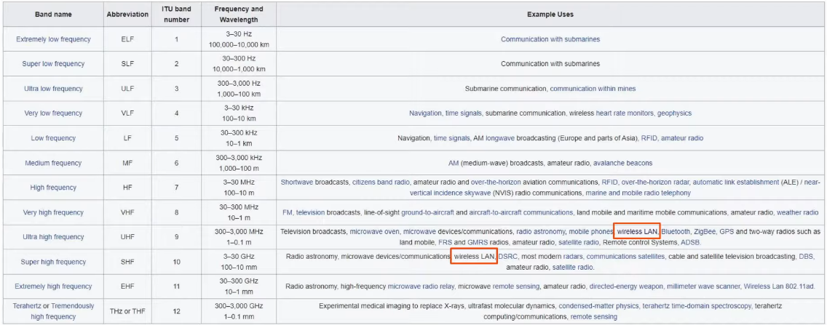

Radio Frequency Bands

* Wi-Fi uses 2 main bands (frequency ranges)
  + 2.4GHz band
    - 2.400GHz - 2.4835GHz
  + 5GHz band
    - 5.150GHz - 5.825GHz
    - Divided into 4

|  |  |
| --- | --- |
| 5.150 - 5. | 250 |

* + - * 5.250 - 5.350
      * 5.470 - 5.725
      * 5.725 - 5.825
* The 2.4GHz band typically provides further reach in open space and better penetration of obstacles such as walls
  + However, more devices tend to use this band so interference can be a bigger problem compared to 5GHz
* Wi-Fi 6 (802.11ax) has expanded the spectrum range to include a band in the 6GHz range

Channels

* Each band is divided up into multiple channels
  + Devices are configured to transmit and receive traffic on 1 (or more) of these channels
* The 2.4GHz band is divided into several channels, each with a 22MHz range

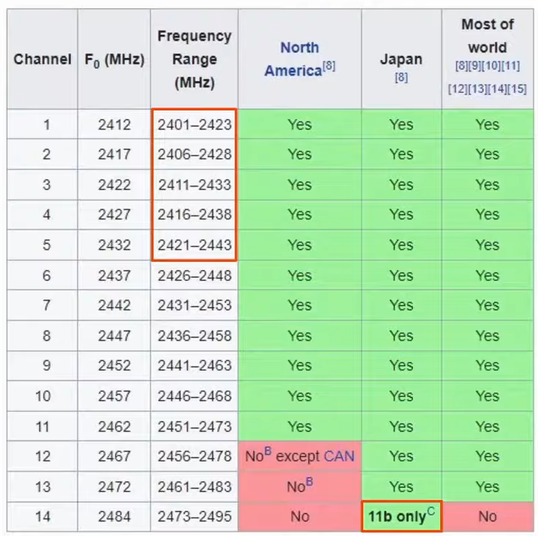

* 11b in Japan is an old technology
* Channels 1- 5 overlap each other, so if wireless points are next to each other, need to be careful which channels to choose

* In a small wireless LAN with only a single AP, can use any channel
* However, in larger WLANs with multiple APs, it's important that adjacent APs don't use overlapping channels
  + Help avoid interference
* In the 2.4GHz band, it is recommended to use channels 1, 6 and 11

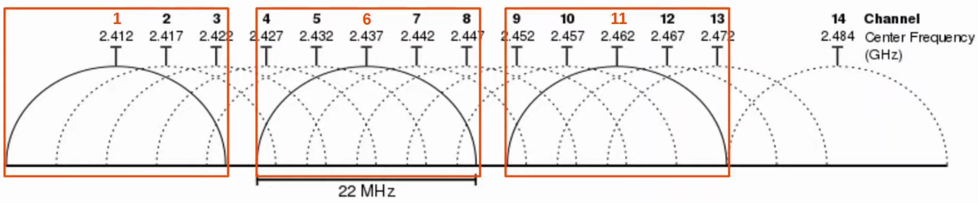

* Outside of North America, can use other combinations, but for CCNA - 1, 6, 11
* The 5GHz band consists of non-overlapping channels, so it is much easier to avoid interference btw adjacent APs
* Using channels 1, 6 and 11, you can place APs in a honeycomb pattern to provide a complete coverage of an area w/o interference btw channels

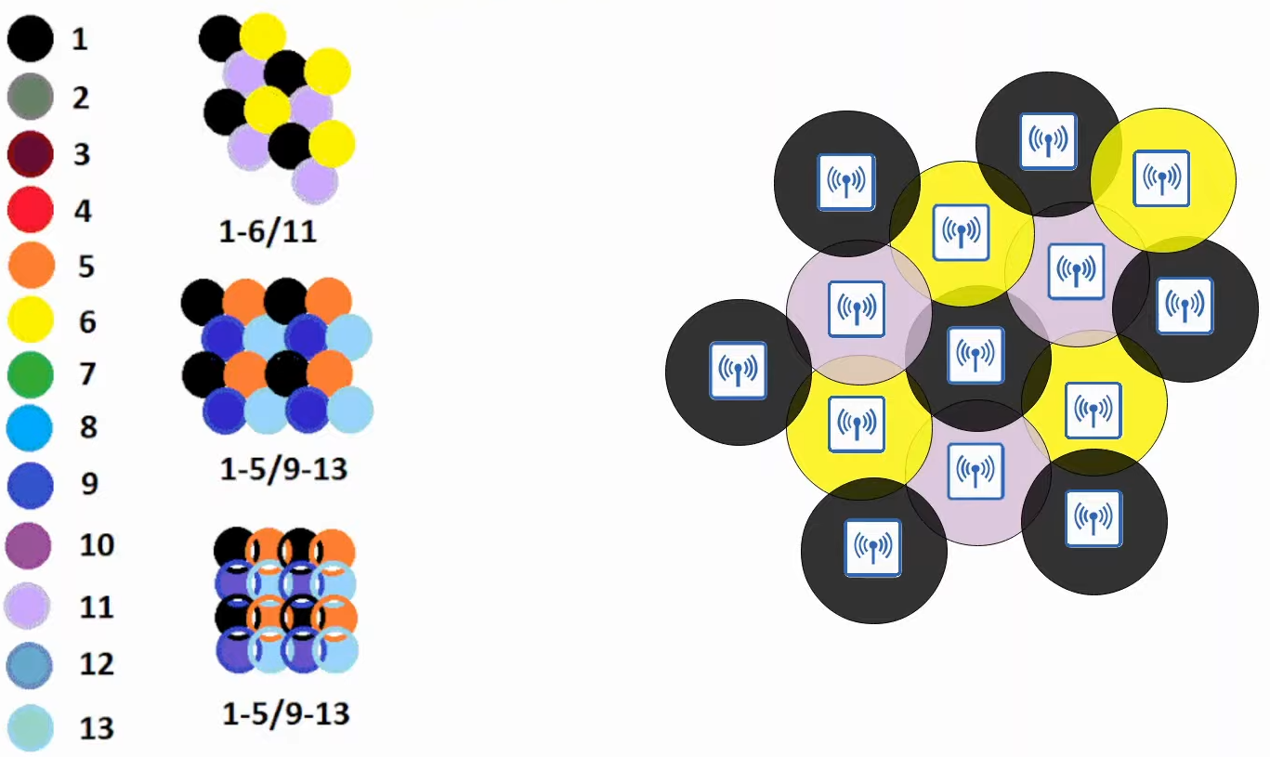

* The pattern on the left include combinations from the rest of the world

802.11 Standards

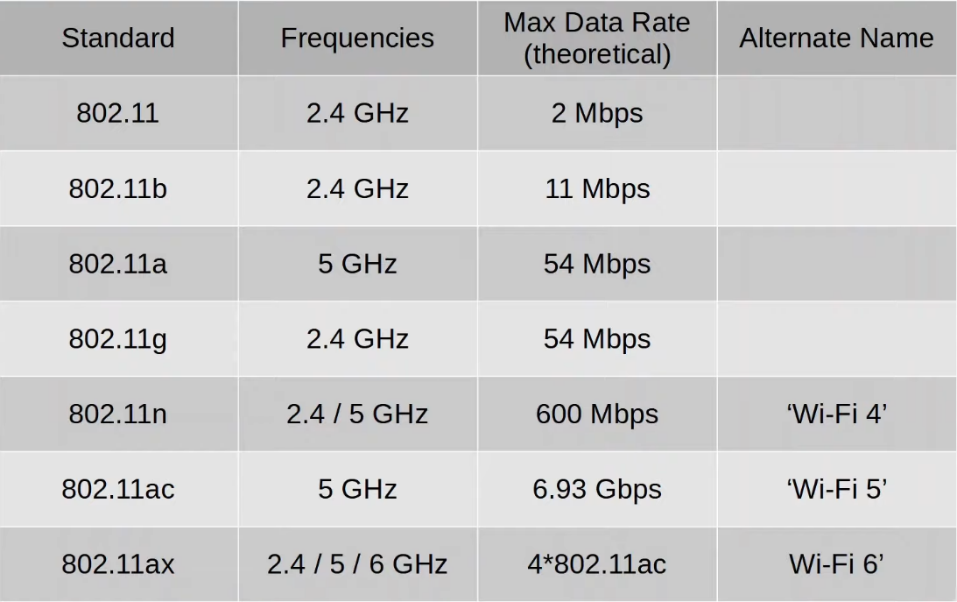

Service Sets

* 802.11 defines different kinds of service sets which are groups of wireless network devices
* There are 3 main types
  + Independent
  + Infrastructure
  + Mesh
* All devices in a service set share the same SSID (service set identifier)
* The SSID is a human-readable name which identifies the service set
* The SSID does not have to be unique

IBSS (Independent Basic Service Set)

* A wireless network in which 2 or more wireless device connect directly without using an AP (Access Point)
* Also called 'ad hoc network'
* Can be used for file transfer (e.g. AirDrop)
* Not scalable beyond a few devices

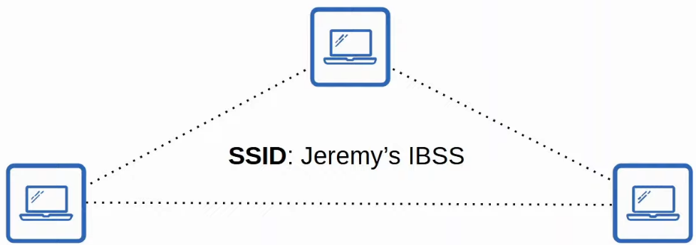

BSS (Basic Service Set)

* It is a kind of Infrastructure Service Set in which clients connect to each other via an AP (access point), but not directly to each other
* A BSSID (BSS ID) is used to uniquely identify the AP
  + Other APs can use the same SSID, but not the same BSSID
  + The BSSID is the MAC address of the AP's radio
* Wireless devices request to associate with the BSS
* Wireless devices that have associated with the BSS are called 'clients' or 'stations'
* *Clients must communicate via the AP and not with each other
* *The area around an AP where the its signal is usable is called a BSA (Basic Service Area)
* BSS is a group of devices
* BSA is an area

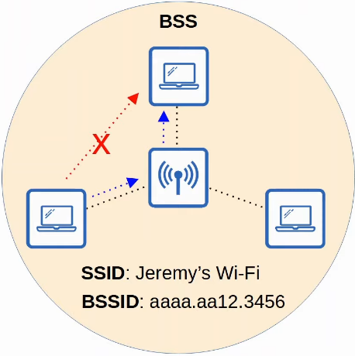

ESS (Extended Service Set)

* To create larger wireless LANs beyond the range of a single AP, use an ESS
* APs with their own BSS are connected by a wired network
  + Each BSS uses the same SSID
  + Each BSS has a unique BSSID
  + Each BSS uses a different channel to avoid interference
* Clients can pass btw APs w/o having to reconnect, providing a seamless Wi-Fi experience when moving btw APs
  + Called 'roaming'
* The BSA should overlap 10-15%

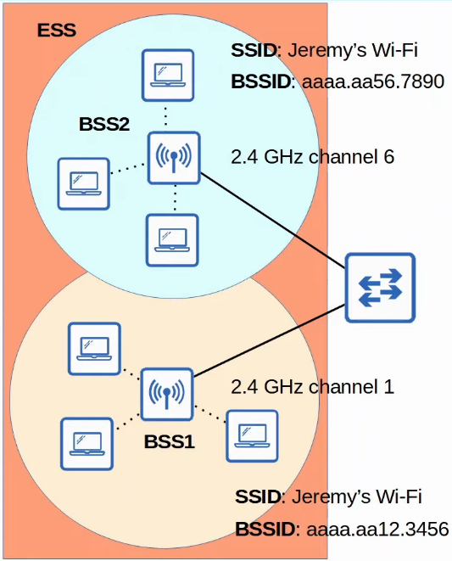

MBSS (Mesh Basic Service Set)

* Used in situations where it’s difficult to run an Ethernet connection to every AP
* Mesh APs use 2 radios
  + 1 to provide a BSS to wireless clients
  + 1 to form a 'backhaul network' which is used to bridge traffic from AP to AP
* At least 1 AP is connected to the wired network, and it is called the RAP (Root Access Point)
* The other APs are called MAP (Mesh Access Points)
* A protocol is used to determine the best route through the mesh (similar to how dynamic routing protocols are used to determine the best path to a destination)

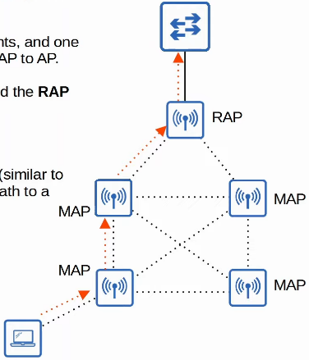

Distribution System

* Most wireless networks aren't standalone networks
  + Rather, they are a way for clients to connect to the wired network infrastructure
* In 802.11, the upstream wired network is called the DS (distribution system)
* Each wireless BSS or ESS is mapped to a VLAN in the wired network

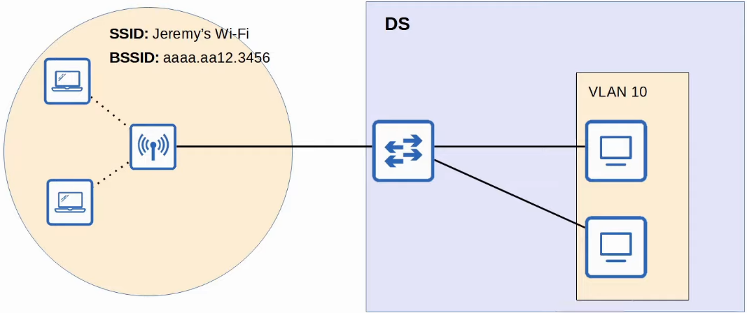

* It's possible for an AP to provide multiple wireless LANs, each with a unique SSID
* Each WLAN is mapped to a separate VLAN and connected to the wired network via a trunk
* Each WLAN uses a unique BSSID, usually by incrementing the last digit of the BSSID by 1

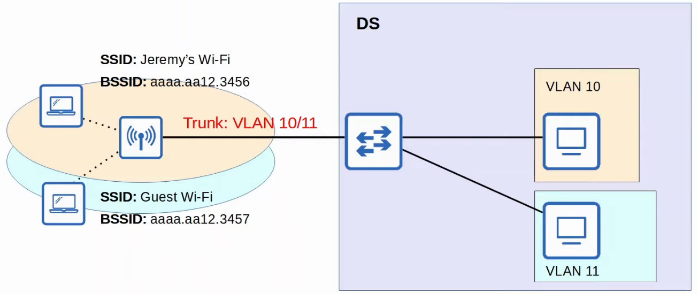

Additional AP Operational Modes

* APs can operate in additional modes beyond the ones we have introduced so far
* An AP in repeater mode can be used to extend the range of a BSS
* The repeater will simply retransmit any signal it receives from the AP
  + A repeater with a single radio must operate on the same channel as the AP, but this can drastically reduce the overall throughput on the channel
  + A repeater with 2 radios can receive on 1 channel, and then retransmit on another channel

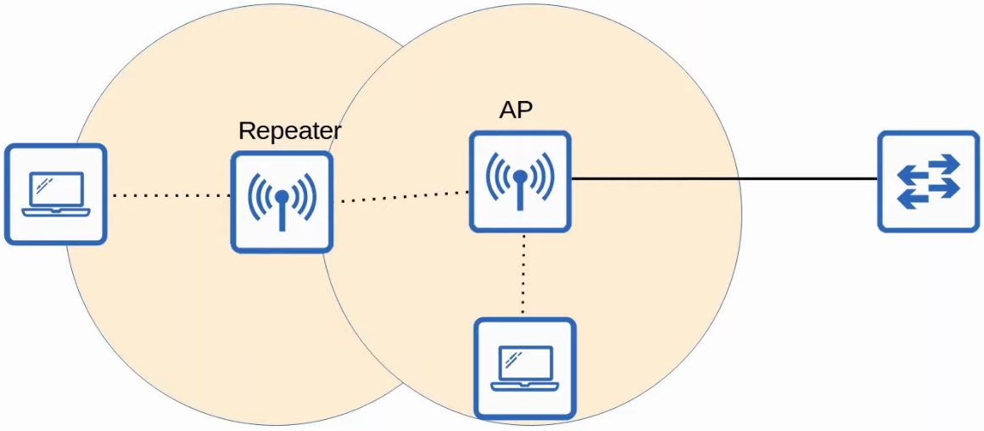

* A workgroup bridge (WGB) operates a wireless client of another AP, and can be used to connect wired devices to the wireless network
* In the example below, PC1 does not have wireless capabilities, and also does not have access to wired connection to SW1
* PC1 has a wired connection to the WGB, which has a wireless connection to the AP
* There are 2 kinds of WGB
  + Universal WGB (uWGB): an 802.11 standard that allows 1 device to be bridged to the wireless network
  + WGB: Cisco proprietary version of the 802.11 standard that allows multiple wired clients to be bridged to the wireless network

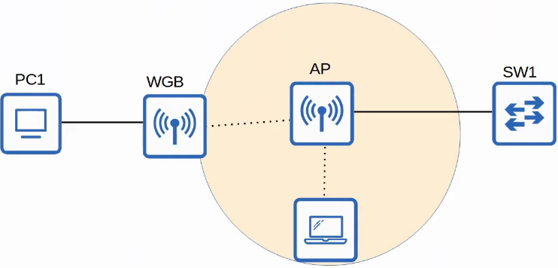

* Outdoor Bridge
  + Can be used to connect networks over long distances w/o a physical cable connecting them
  + The APs will use specialized antennas that focus most of the signal power in 1 direction, which allows the wireless connection to be made over longer distances than normally possible
  + The connection can be point-to-point as in the diagram below, or point-to-multipoint in which multiple sites connect to 1 central site

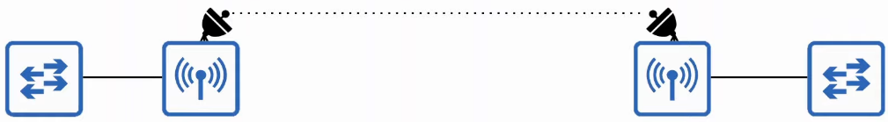

Review

• Wireless LANs are defined in 802.11.

* Operate in half duplex using CSMA/CA

• Wireless signals can be affected by absorption, reflection, refraction, diffraction, and scattering.

• Various aspects of waves can be measured, such as amplitude, frequency, and period.

• Frequency is measured in hertz (Hz).

• Wireless LANs use two frequency ranges: the 2.4 GHz band and 5 GHz band.

-4 WI-Fi 6 (802.11ax) can use the 6 GHz range too.

• Bands are divided into channels.

• 5 GHz band consists of non-overlapping channels.

• 2.4 GHz band channels overlap. To avoid overlapping, use channels 1, 6, and 11 (in North America).

• 802.11 standards (802.11b, 802.11a, etc) and their frequencies/theoretical max data rates.

Service sets are groups of wireless devices. Three types:

* Independent (IBSS, also called ad hoc)
* Infrastructure (BSS, ESS)

*passing between APS in an ESS is called roaming.

* Mesh (MBSS)

• Service sets are identified by an SSID (non-unique, human-readable) and BSSID (unique, MAC address of AP).

• The area around an AP where its signal is usable is called a BSA.

• The upstream wired network is called the DS.

• When multiple WLANs are used, each is mapped to a separate VLAN on the wired network.

• APS can also operate as a repeater, workgroup bridge, or outdoor bridge.

*Although this summarizes the topics in this video, make sure you know the details of each topic that we covered.

## Wireless Architecture

Things covered

* 802.11 messages/frame format
* Autonomous APs
* Lightweight APs
* Cloud-based APs
* Wireless LAN Controller (WLC) Deployments

802.11 Frame Format

* Depending on the 802.11 version and messaging type, some of the fields might not be present in the frame
  + E.g. not all messages use all 4 address fields



* Frame control
  + Provides information such as the message type and subtype
* Duration/ID
  + Depending on the message type, this field can indicate
    - Time (in microseconds) the channel will be dedicated for transmission of the frame
    - Identifier for the association (connection)
* Addresses
  + Up to 4 addresses can be present in an 802.11 frame
  + Which addresses are present, their order, depends on the message type
  + Destination Address (DA) - final recipient of the frame
  + Source Address (SA) - original sender of the frame
  + Receiver Address (RA) - immediate recipient of the frame
  + Transmitter Address (TA) - immediate sender of the frame
* Sequence Control
  + Used to reassemble fragments and eliminate duplicate frames
* HT (High Throughput) Control
  + Added in 802.11n to enable High Throughput operations
  + 802.11n - High Throughput (HT) Wi-Fi
  + 802.11ac - Very High Throughput (VHT) Wi-Fi
* FCS (Frame Check Sequence)
  + Same as in Ethernet frame, used to check for errors

802.11 Association Process

* Access Points bridge traffic btw wireless stations and other devices
* For a station to send traffic through the AP, it must be associated with the AP
* There are three 802.11 connection states
  + Not authenticated, not associated
  + Authenticated, not associated
  + Authenticated, associated
* The station must be fully authenticated and associated with the AP to send traffic through it
* Note: there are 2 ways for a station to scan for a BSS
  + Active scanning
    - The station sends 'probe' requests and listens for a probe response from an AP
    - Shown in example below
  + Passive scanning
    - The station listens for beacon message from an AP
    - Beacon messages are sent periodically by APs to advertise the BSS

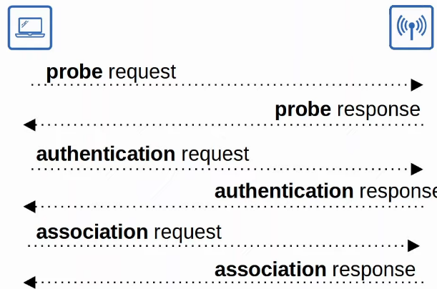

802.11 Message Types

* There are 3 message types
  + Management
    - Used to manage the BSS
    - E.g. Beacon, Probe request/response, Authentication, Association
  + Control
    - Used to control access to a medium (radio frequency)
    - Assist with delivery of management and data frames
    - E.g. RTS (Request to Send), CTS (Clear to Send), ACK
  + Data
    - Used to send actual data packets

Wireless AP Deployment

* There are 3 main wireless AP deployment methods
  + Autonomous
  + Lightweight
  + Cloud-based

Autonomous APs

* Self-contained systems that don't rely on a WLC
* They are configured individually
  + Can be configured by console cable (CLI), telnet/SSH (CLI), or HTTP/HTTPS web connections (GUI)
  + An IP address for remote management should be configured
  + The RF parameters must be manually configured (transmit power, channel, etc)
  + Security policies are handled individually by each AP
  + QoS rules etc, are configured individually on each AP
* There is no central monitoring or management APs

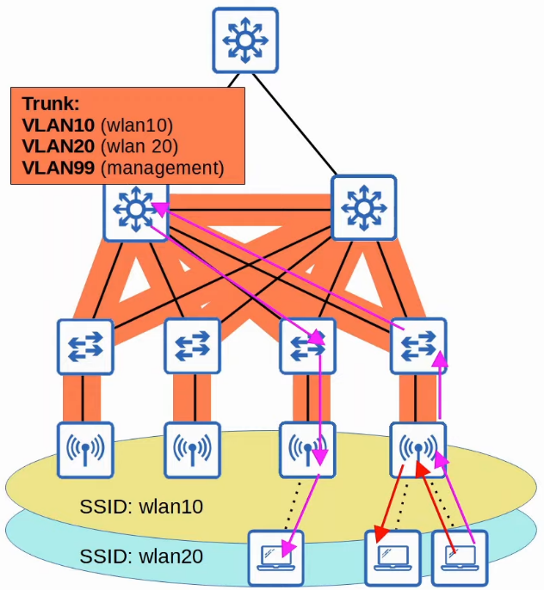

* Autonomous APs connect to the wired network with a trunk link
  + Separate management traffic with regular data traffic
* Data traffic from wireless clients has a very direct path to the wired network or to other wireless clients associated with the same AP
* Each VLAN has to stretch across the entire network, which is bad as
  + Large broadcast domains
  + Spanning tree will disable links
  + Adding/deleting VLANs is very labour-intensive
* Autonomous APs can be used in small networks, but they are not viable in medium to large networks
  + Large networks can have thousands of APs
* Autonomous APs can also function in the modes covered in the previous video
  + Repeater, Outdoor Bridge, Workgroup bridge

Lightweight APs

* The functions of the AP can be split btw the AP and the WLC (Wireless LAN Controller)
* Lightweight APs handle all the real-time operations
  + E.g. transmitting/receiving RF traffic, encryption/decryption of traffic, sending out beacons/probes etc
* Other functions are carried out by a WLC
  + E.g. RF management, security/QoS management, client authentication, client association/roaming management etc
* Called 'split-MAC architecture'
* WLC also used to centrally configure the lightweight APs
* WLC can be located in the same/different subnet/VLAN as the lightweight APs it manages
* The WLC and the lightweight APs authenticate each other using digital certificates installed on each device
  + X.509 standard certificates
  + Ensures that only authorized APs can join the network

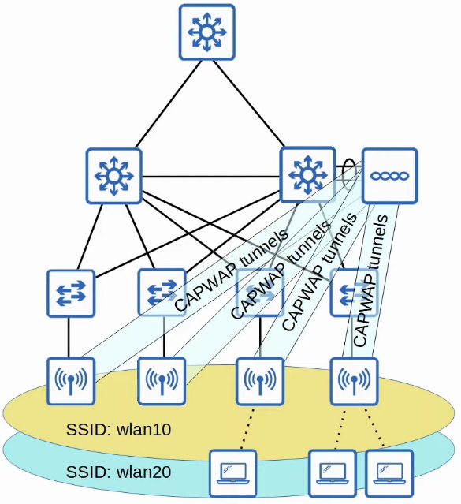

* The WLC and lightweight APs use a protocol called CAPWAP (Control and Provisioning of Wireless Access Points) to communicate
  + Based on an older protocol called LWAPP (Lightweight Access Point Control)
* 2 tunnels are created btw each AP and the WLC
  + Control tunnel
    - UDP port 5246
    - Used to configure the APs, and control/manage the operations
    - All traffic is encrypted by default
  + Data tunnel
    - UDP port 5247
    - All traffic from wireless clients is sent through this tunnel to the WLC. It does not go directly to the wired network
    - Traffic not encrypted by default, but can configure it with encryption with DTLS (Datagram Transport Layer Security)
* Because all traffic from wireless clients is tunnelled to the WLC with CAPWAP , APs connect to switch access ports, not trunk ports

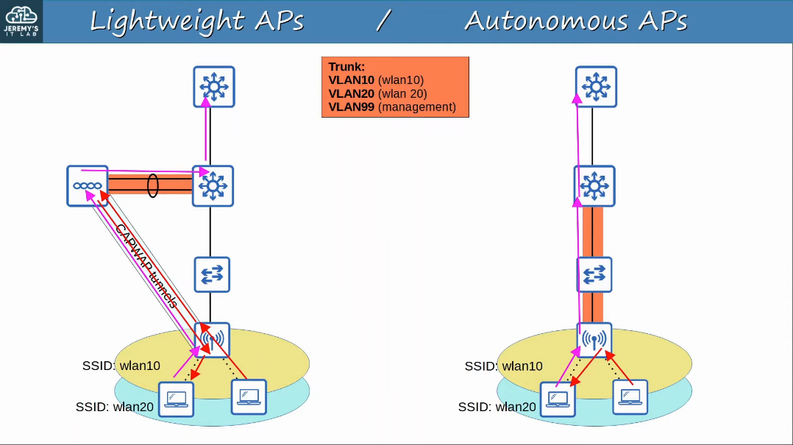

* Benefits
  + Scalability
    - With a WLC (or multiple) it's much simpler to build and support a network with thousands of APs
  + Dynamic channel assignment
    - WLC can auto select which channel each AP should use
  + Transmit power optimization
    - WLC can auto set the appropriate transmit power for each AP
  + Self-healing wireless coverage
    - When an AP stops functioning, the WLC can increase the transmit power of nearby AP's to avoid coverage holes
  + Seamless roaming
    - Clients can roam between APs with no noticeable delay
  + Client load balancing
    - If a client is in range of 2 APs, the WLC can associate the client with the least-used AP, to balance the load among APs
  + Security/QoS management
    - Central management of security and QoS policies ensures consistency across the network

* Lightweight APs can be configured to operate in different modes
  + Local
    - Default
    - AP offers a BSS (or multiple) for clients to associate with
  + FlexConnect
    - Offers 1 or more BSS for clients to associate with (like Local)
    - Allows APs to locally switch traffic btw the wired and wireless networks if the tunnels to the WLC goes down

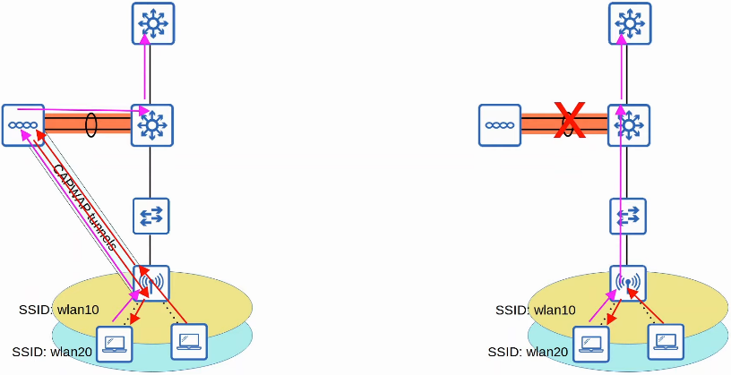

* Sniffer
  + AP does not offer BSS for clients
  + It is dedicated to capturing 802.11 frames and sending them to a device software such as Wireshark
* Monitor
  + Dedicated to receiving 802.11 frames to detect rogue devices
  + If client found to be a rogue device, the AP can send de-authentication messages to disassociate the rogue device from the AP
* Rogue detector
  + AP does not use its radio
  + Listens to traffic on the wired network only
  + Receives a list of suspected rogue clients and AP MAC addresses from the WLC
  + By listening to ARP messages on the wired network and correlating it with the info it receives from the WLC, it can detect rogue devices
* SE-Connect (Spectrum Expert Connect)
  + AP does not offer BSS for clients
  + Dedicated to RF spectrum analysis on all channels
  + Can send info to software such as Cisco Spectrum Expert on a PC to collect and analyse the data
  + Can help find sources of interference
* Bridge/Mesh
  + Lightweight AP can be a dedicated bridge btw sites, e.g. over long distances
  + A mesh can be made btw the access points
* Flex plus Bridge
  + Adds FlexConnect functionality to the Bridge/Mesh mode
  + Allows wireless access points to locally forward traffic even if connectivity to the WLC is lost

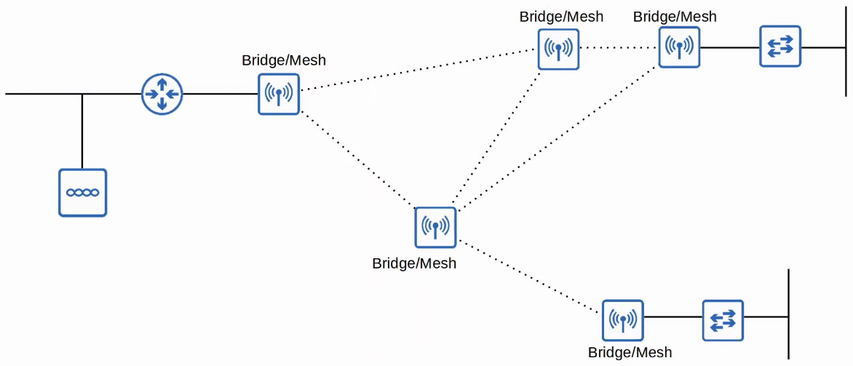

Cloud-based APs

* Cloud-based AP architecture is in btw autonomous AP and split-MAC architecture
  + Autonomous APs that are centrally managed in the cloud
* Cisco Meraki is a popular cloud-based Wi-Fi solution
* The Meraki dashboard can be used to configure APs , monitor the network, generate performance reports, etc
  + Meraki also tells each AP which channel to use, what transmit power, etc
* However, data traffic is not sent to the cloud
  + It is sent directly to the wired network like when using autonomous APs
  + Only management/control traffic is sent to the cloud

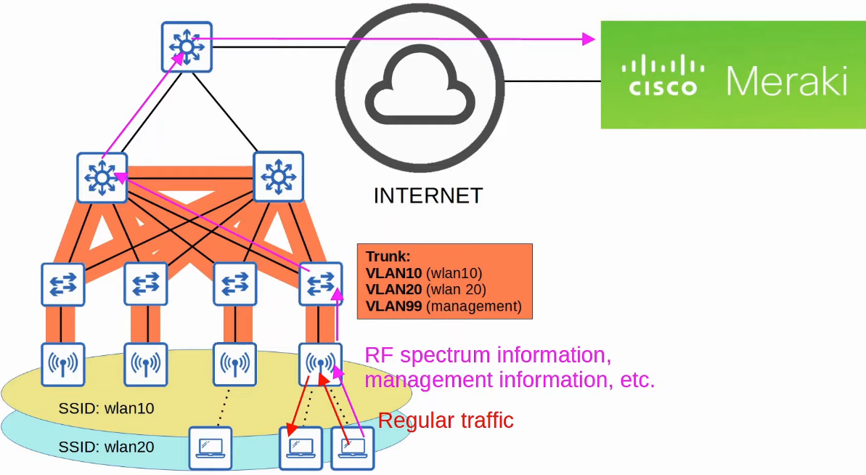

WLC Deployment Models

* In a split-MAC architecture, there are 4 main WLC deployment models
  + Unified
    - The WLC is a hardware appliance in a central location of the network
  + Cloud-based
    - The WLC is a VM running on a server, usually in a private cloud in a data center
    - This is not the same as the cloud-based AP architecture discussed previously
  + Embedded
    - The WLC is integrated within a switch
  + Mobility Express
    - The WLC is integrated within an AP

Unified WLC

* Hardware appliance deployed in a central location of the network
* Can support up to 6000 APs
* If more APs needed, additional WLCs can be added to the network

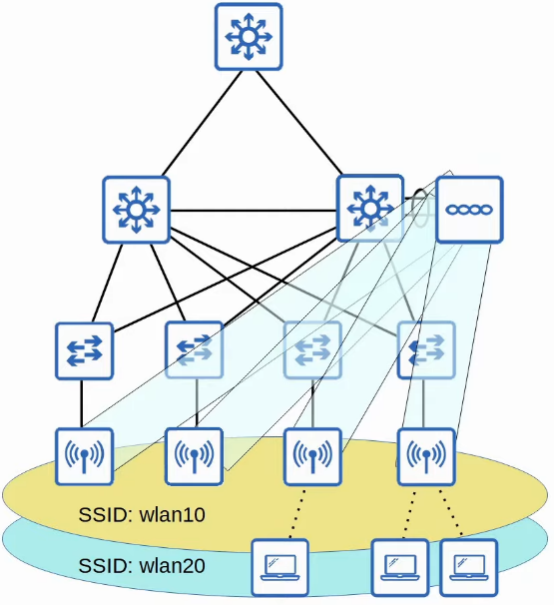

Cloud-based WLC

* WLC is a VM running on a server, typically in a private cloud or data center
* Can support up to 3000 APs
* If more APs needed, more WLCs can be added

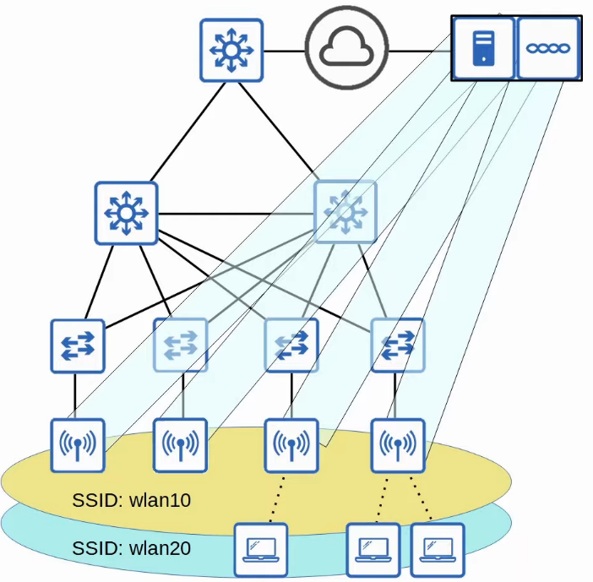

Embedded WLC

* Embedded within a switch
* Can support up to 200 APs
* If more APs needed, can add more switches with embedded WLC

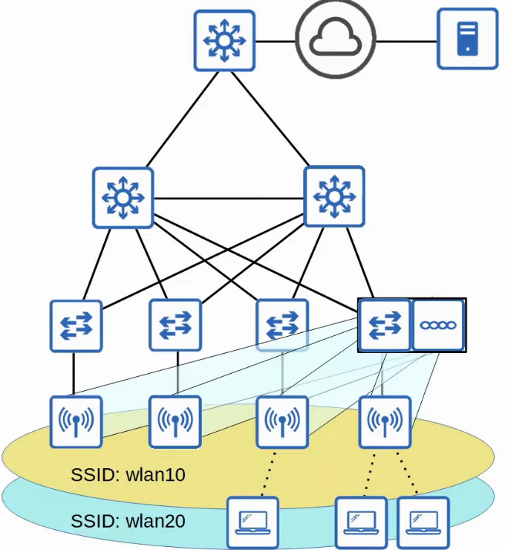

Cisco Mobility Express WLC

* Embedded within an AP
* Support up to 100 APs
* If more needed, can add more APs with embedded Mobility Express WLC

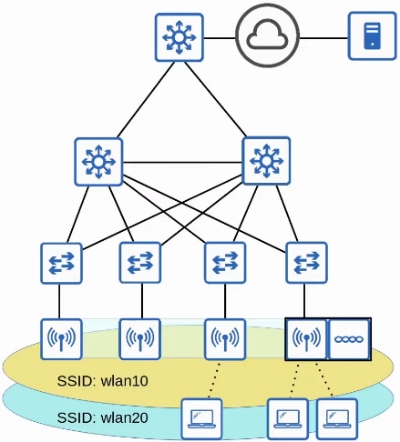

## Wireless Security

Things Covered

* Intro
* Authentication Methods
* Encryption/Integrity methods
* Wi-Fi Protected Access (WPA)

**Intro**

* More important in wireless network
  + Wireless signals not contained within wire, any device within signal range can receive traffic
* Encryption
  + Wired networks encrypted only when sent over untrusted networks e.g. Internet
  + Wireless networks, important to encrypt traffic btw wireless clients and AP
* 3 main concepts
  + Authentication
  + Encryption
  + Integrity

**Authentication**

* All clients must be authenticated before they can associate with AP
* In corporate settings, only trusted devices should be given access to network
  + Separate SSID which doesn't have access to corporate network can be used for guests
* Clients should also authenticate AP to avoid associating with malicious AP
* Multiple ways to authenticate
  + Password
  + Username / Password
  + Certificates

**Encryption**

* Any wireless traffic should be encrypted
* Many protocols
  + Both client and AP need to have the same protocol
* All devices in WLAN will use same protocol
  + However, each client will use a unique encryption/decryption key
* 'Group key' used by AP to send to all clients
  + All clients associated with AP will also have the key

**Integrity**

* Ensures that traffic is not modified in transit
* MIC (Message Integrity Check) is added to check the integrity

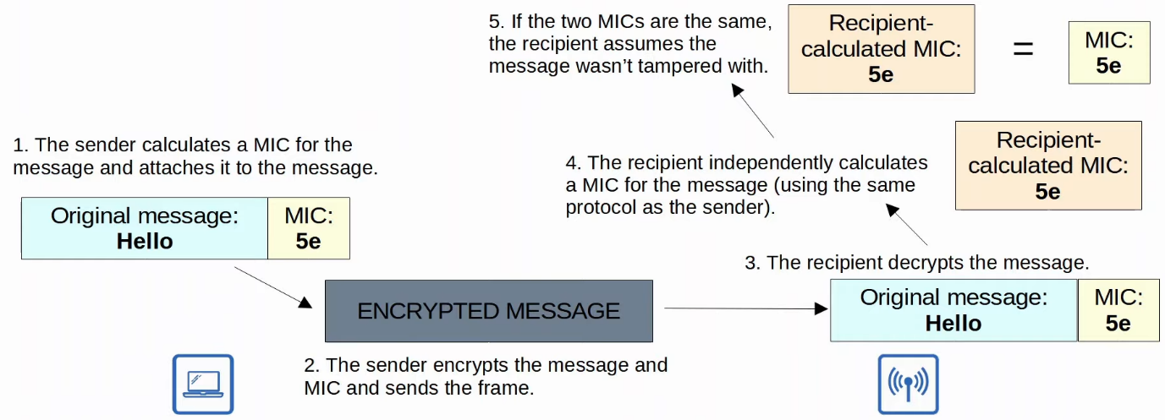

**Authentication Methods**

* Open Authentication
* WEP (Wired Equivalent Privacy)
* EAP (Extensible Authentication Protocol)
* LEAP (Lightweight EAP)
* EAP-FAST (EAP Flexible Authentication via Secure Tunnelling)
* PEAP (Protected EAP)
* EAP-TLS (EAP Transport Layer Security)

**Open Authentication**

* Client send authentication request, AP accepts it, no questions asked
* Not secure
* Possible after authentication, user need to authenticate via another method before granted access to network
* E.g. Airport Wi-Fi

**WEP (Wired Equivalent Privacy)**

* Provide authentication and encryption
* Encryption
  + RC4 algorithm
  + 'Shared-key' protocol, AP and client have same key
  + Key: 40/104 bits + 24 bit IV (Initialisation Vector)
    - Total: 64/128 bits
  + Not secure, easily cracked
* Authentication

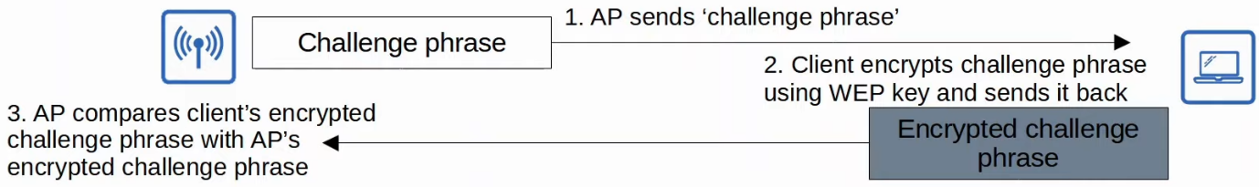

**EAP (Extensible Authentication Protocol)**

* It is an authentication framework
* Defines a standard set of authentication functions that are used by various EAP methods
* EAP is integrated with 802.1X, which provides port-based network access control

**802.1X**

* Used to limit network access for clients connected to a LAN or WLAN until they authenticate
* 3 main entities
  + Supplicant
    - Device that wants to connect to the network
  + Authenticator
    - Device that provides the access to the network
  + Authentication Server
    - Device that receives client credentials and permit/denies access
* When connected through open authentication, only EAP authentication allowed, all other traffic not allowed

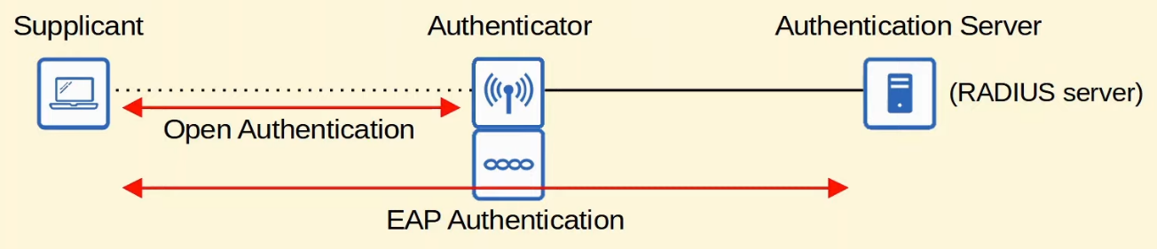

**LEAP (Lightweight EAP)**

* Developed by Cisco as upgrade to WEP
* Client must provide username and password to authenticate
* In addition, mutual authentication is provided by both the client and server sending a challenge phrase to each other
* Dynamic WEP keys are used, meaning the WEP keys are changed frequently
* Considered vulnerable and should not be used

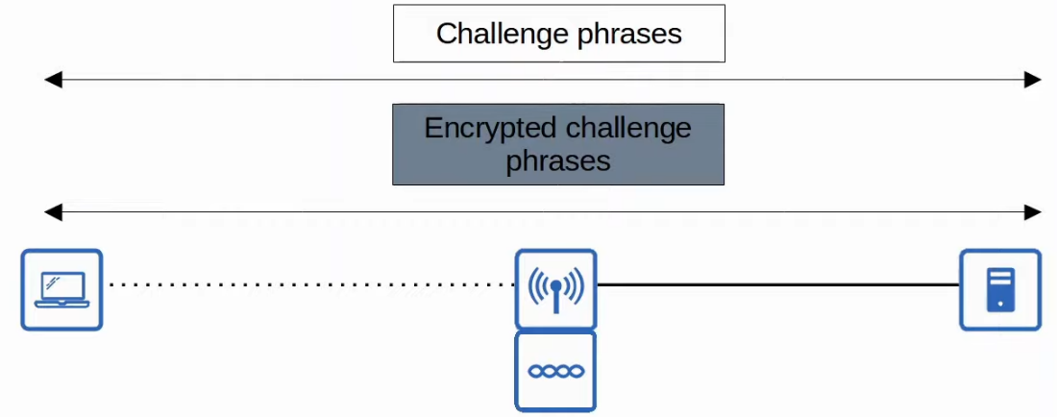

**EAP-FAST (EAP Flexible Authentication via Secure Tunnelling)**

* Developed by Cisco
* 3 phases
  1. A PAC (Protected Access Credential) is generated and passed from server to client
  2. A secure TLS Tunnel is established btw the client and authentication server
  3. Inside of the secure (encrypted) TLS tunnel, the client and server communicate further to authenticate/authorize the client

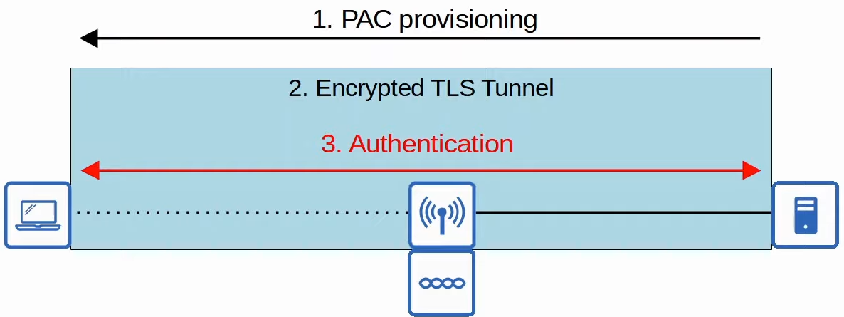

**PEAP (Protected EAP)**

* Like EAP-FAST, involves establishing a secure TLS tunnel btw client and server
* Use digital certificate instead of PAC
  + Used by client to authenticate server
  + Used to establish TLS tunnel
* Because only the server provides a certificate for authentication, the client must still be authenticated within the secure tunnel
  + E.g. using MS-CHAP (Microsoft Challenge-Handshake Authentication Protocol)

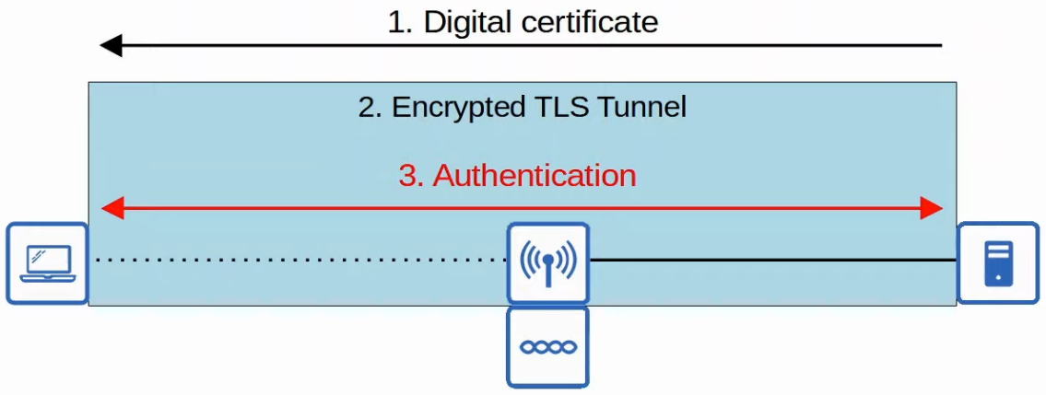

**EAP-TLS (EAP Transport Layer Security)**

* AS (Authentication Server) and all clients need to have digital certificates
* Most secure, but difficult to implement as all clients need to have cert
* Since client and server authenticate each other with digital cert, no need to authenticate client within the TLS tunnel
* TLS tunnel still used to exchange encryption key information

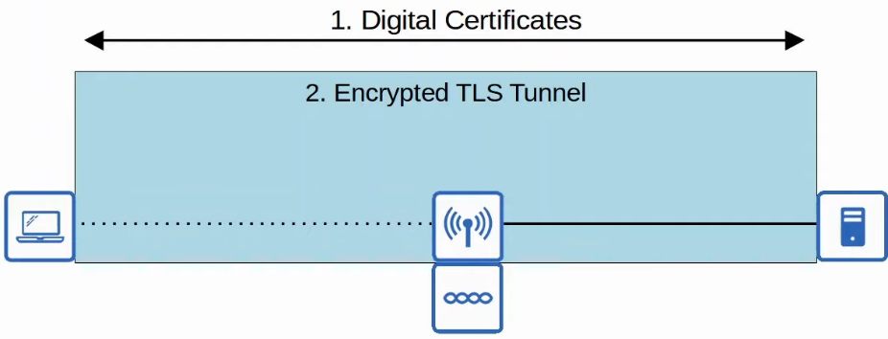

**Encryption/Integrity Methods**

* TKIP (Temporal Key Integrity Protocol)
* CCMP (Counter/CBC-MAC Protocol)
* GCMP (Galois/Counter Mode Protocol)

**Temporal Key Integrity Protocol (TKIP)**

* Temporary solution for WEP since most devices were built for WEP
* Added security features
  + MIC added
  + Key mixing algorithm used to create unique WEP keys for every frame
  + Initialization vector doubled to 48 bits, making brute-force attacks more difficult
  + MIC includes sender MAC address
  + Timestamp added to MIC to prevent replay attacks
    - Replay attacks involve sending a frame that has already been transmitted
  + TKIP sequence number used to keep track of frames sent from each source MAC address
    - Also protects against replay attacks
* Note:
  + Used in WPA version 1
  + Just know that it is an upgrade to WEP

**Counter/CBC-MAC Protocol (CCMP)**

* Developed after TKIP, more secure
* WPA2
* Must be supported by hardware
* 2 different algorithm for encryption and MIC
  + AES (Advanced Encryption Standard)
    - 'Counter' mode
    - Most secure encryption in the world
    - Multiple modes, CCMP uses 'counter'
  + CBC-MAC (Cipher Block Chaining Messages Authentication Code)
    - Used as MIC

**Galois/Counter Mode Protocol (GCMP)**

* More secure and efficient than CCMP
* Higher data throughput than CCMP
* WPA3
* 2 algorithms
  + AES counter mode
  + GMAC (Galois Message Authentication Code)
    - MIC

**Wi-Fi Protected Access**

* Wi-Fi Alliance has developed 3 WPA certifications for wireless devices
  + WPA
  + WPA2
  + WPA3
* To be WPA-certified, equipment must be tested and authorized
* All WPA support 2 authentication modes
  + Personal mode
    - Pre-shared key (PSK) used for authentication
    - E.g. connect to home wifi, enter the password and are authenticated
    - Common for small networks
    - Note: PSK not sent over air. A 4-way handshake is used for authentication, and the PSK is used to generate the encryption keys
  + Enterprise mode
    - 802.1X is used with an authentication server (RADIUS server)
    - *No specific EAP method specified, all are supported

**WPA**

* Developed after WEP proven to be vulnerable
* Consist of the following protocols
  + TKIP (based on WEP) provides encryption/MIC
  + 802.1X authentication (Enterprise mode) or PSK (Personal mode)

**WPA2**

* Released 2004
* Protocols
  + CCMP provides encryption/MIC
  + 802.1X authentication (Enterprise mode) or PSK (Personal mode)

**WPA3**

* Released 2018
* Protocols
  + GCMP provides encryption/MIC
  + 802.1X authentication (Enterprise mode) or PSK (Personal mode)
  + Have additional security features
    - PMF (Protected Management Frames)
      * Protect 802.11 frames from eavesdropping/forging
    - SAE (Simultaneous Authentication of Equals)
      * Protects the 4-way handshake when using personal mode authentication
    - Forward Secrecy
      * Prevents data from being decrypted after it has been transmitted over the air
      * An attacker can't capture wireless frames and then try to decrypt them later

# Network Automation

## Network Automation

Things covered

* Why network automation
* Benefits
* Logical 'planes' of network functions
* Software-defined networking (SDN)
* APIs
* Data Serialization

**Network Automation**

* In traditional model, engineers manage devices one at a time by connecting to their CLI
* Disadvantages
  + Typos and small mistakes are common
  + It is time-consuming and very inefficient in large-scale networks
  + Difficult to ensure all devices adhere to the organization's standard configurations
* Network automation provides many benefits
  + Human error reduced
  + Networks become much more scalable. New deployments, network-wide changes, and troubleshooting can be implemented in a fraction of the time
  + Network wide policy compliance can be assured
  + The improved efficiency of network operations reduces the opex (operation expenses) of the network. Each task requires fewer man-hours
* There are various tools/methods that can be used to automate tasks in the network
  + SDN (Software-Defined Networking)
  + Ansible
  + Puppet
  + Python scripts
  + Etc

**Logical Planes**

* The various functions of network devices can be logically divided into planes
  + Data plane
  + Control plane
  + Management plane

**Data Plane**

* All tasks involved in forwarding user data/traffic from 1 interface to another are part of the data plane
* Also called 'forwarding plane'
* Example
  + A router receives a message, looks for the most specific matching route in its routing table, and forwards it out of the appropriate interface to the next hop
    - It also de-encapsulates the original Layer 2 header, and re-encapsulates with a new header destined for the next hop's MAC address
  + A switch receives a message, looks at the destination MAC address, and forwards it out of the appropriate interface (or floods it)
    - This includes functions like adding or removing 802.1Q VLAN tags
  + NAT (changing the src/dst address before forwarding) is part of the data plane
  + Deciding to forward or discard messages due to ACLs, port security, etc is part of the data plane

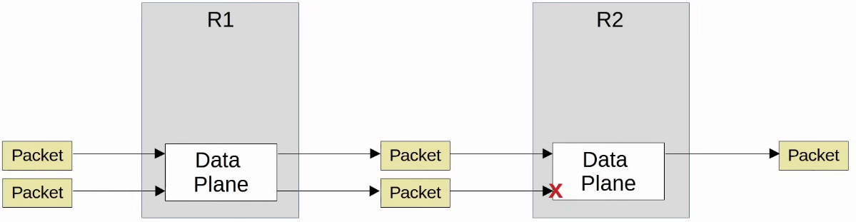

**Control Plane**

* How does a device's data plane make its forwarding decisions?
  + Routing table, MAC address table, ARP table, STP, etc
* Functions that build these tables (and other functions that influence the data plane) are part of the control plane
* The control plane controls what the data plane does, e.g. by building the router's routing table
* The control plane performs overhead work
  + E.g. OSPF itself does not forward user packet, but it informs the data plane how packets should be forwarded
  + E.g. STP - which interface should/shouldn't forward frames
  + E.g. ARP - build ARP table that is used in the process of forwarding data

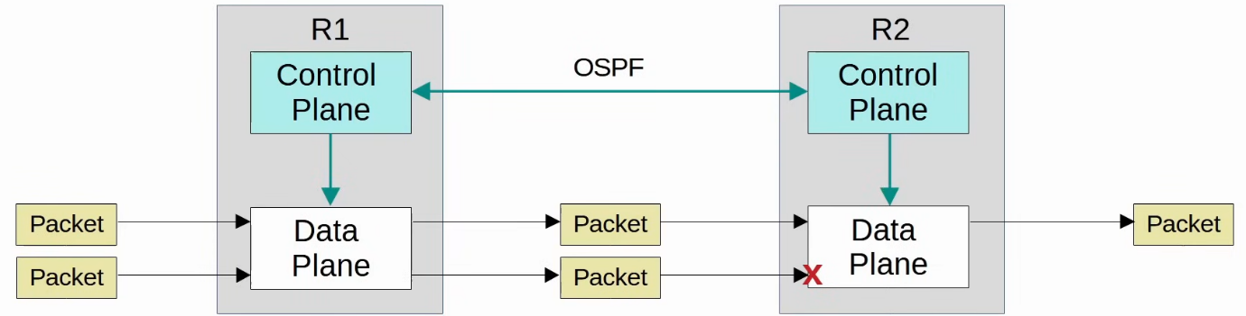

* In traditional networking, the data plane and control plane are both distributed
  + Each device has its own data and control plane
  + The planes are 'distributed' throughout the network

**Management Plane**

* Performs overhead work
* Doesn't directly affect the forwarding of messages in the data plane
* Consists of protocols that are used to manage devices
  + SSH/Telnet - used to connect to the CLI of the device
  + Syslog - used to keep logs of events that occur on the device
  + SNMP - used to monitor the operations of the device
  + NTP - used to maintain accurate time on the device

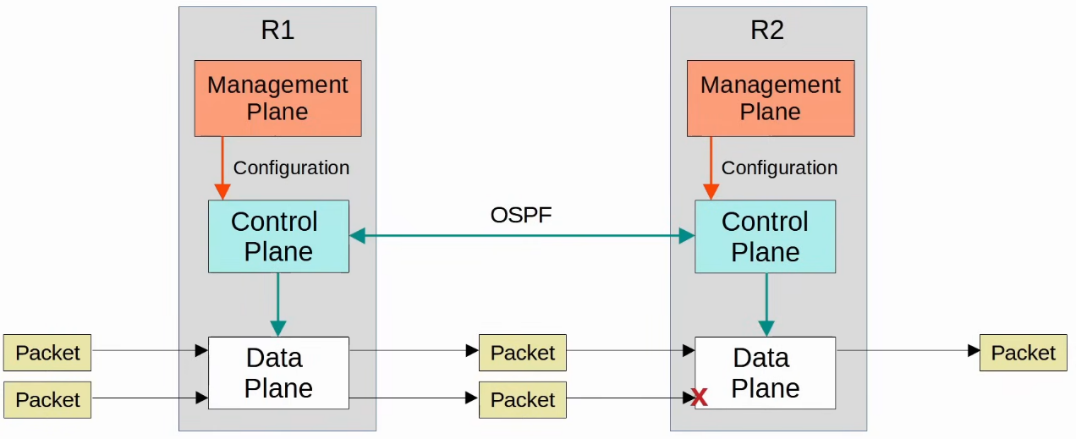

* The data plane is the reason why we buy routers and switches (and network infrastructure in general), to forward messages
  + However, the Control plane and Management plane are both necessary to enable the data plane to do its job

**Hardware Management**

* Operations of the Management and Control plane are usually managed by the CPU
* However, not desirable for Data plane operations since CPU processing is slow
* ASIC (Application-Specific Integrated Circuit) used
* Using switch for example
  + When frame is received, ASIC responsible for switching logic
  + MAC address table stored in TCAM (Ternary Content-Addressable Memory)
  + MAC address table also called CAM table
  + ASIC feeds the destination MAC address of frame into TCAM, which returns the matching MAC address table entry
  + The frame is then forwarded out of the appropriate interface
* Modern routers also use a similar hardware data plane
  + ASIC for forwarding logic
  + Tables stored in TCAM
* Simple summary
  + When a device receives control/management traffic (destined for itself), it will be processed by CPU
  + When a device receives data traffic which should pass through the device, it is processed by the ASIC for max speed

**Software-Defined Networking (SDN)**

* An approach to networking that centralizes the control plane into an application called a 'controller'
* SDN also called Software-Defined Architecture (SDA) or Controller-Based Networking
* Traditional control planes use a distributed architecture
  + E.g. each router in the network runs OSPF and the routers share routing information and then calculate their preferred routes to each destination
* An SDN controller centralizes control plane functions (e.g. calculating routes)
  + That is just an example, how much of the control plane is centralized varies greatly
* The controller can interact programmatically with the network devices using APIs (Application Programming Interface)

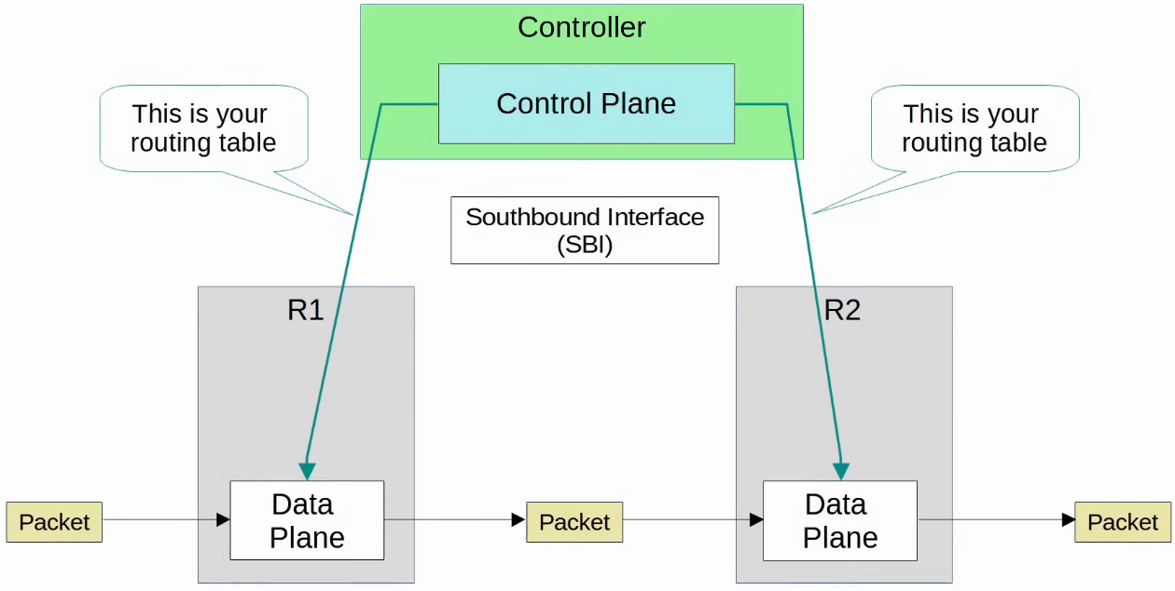

**Southbound Interface (SBI)**

* Used for communication btw controller and network devices it controls
* Typically consists of communication protocol and API
* APIs facilitate data exchanges btw programs
  + Data is exchanged btw controller and network devices
  + An API on the network device allows the controller to access information on the device, control their data plane tables, etc
* Some examples of SBIs
  + OpenFlow
  + Cisco OpFlex
  + Cisco onePK (Open Network Environment Platform Kit)
  + NETCONF

**Northbound Interface (NBI)**

* Allows us (user) to interact with the controller, access data it gathers about the network, program it, and make the changes in the network via SBI
* A REST API is used on the controller as an interface for apps to interact with it
  + REST - Representational State Transfer
* Data is sent in a structured (serialized) format such as JSON/XML
  + Makes it easier for programs to use the data

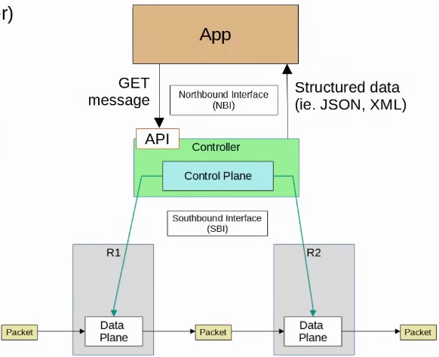

**Automation in Traditional Networks vs SDN**

* Traditional Networks
  + Scripts can be written (e.g. using Python) to push commands to many devices at once
  + Python with good use of 'Regular Expressions' can parse through "show" commands to gather information about the network devices
* However, the robust and centralized data collected by SDN controllers greatly facilitates these functions
  + Controller collects information about all devices in the network
  + Northbound APIs allow apps to access information in a format that is easy for programs to understand (e.g. JSON, XML)
  + The centralized data facilities network-wide analytics
* SDN tools provide the benefits of automation w/o the requirement of 3rd party scripts and apps
  + Don't need to have expertise in automation to make use of SDN tools
  + However, APIs allow 3rd party applications to interact with the controller, which can be very powerful
* Note: Although SDN and automation aren't the same thing, the SDN architecture greatly facilitates the automation of various tasks in the network via the SDN controller and APIs

## AI & Machine Learning

Things covered

* What are AI and ML
* Types of ML
* Predictive/Gen AI
* AI in Catalyst Center

**What is AI**

* AI uses computers to simulate intelligence, allowing them to exhibit behaviour typically associated with humans
* Examples
  + Virtual assistants: Siri, Alexa
  + Recommendation systems: Netflix, YouTube
  + Self-driving cars: Tesla
  + Etc

**Machine Learning (ML)**

* Subset of AI
* Focus on enabling computers to learn from data and improve w/o the need for explicit programming
  + Instead of hard coded instructions, ML algorithms identify patterns in data and make predictions or decisions based on those pattern

**Types of ML**

* Supervised Learning
  + Model trained on labelled data, correct answers provided
  + Make predictions or classification on new data
* Unsupervised Learning
  + Model given unlabelled data
  + Tasked with finding patterns, relationships, or groupings within the data
* Reinforcement Learning
  + Model learns by interacting with an environment
  + Receives rewards/penalties based on its actions to maximise its performance over time
* Deep Learning
  + Specialized subset of ML that uses multi-layered neural network to handle large datasets and perform complex tasks like image recognition and natural language processing

**Supervised Learning**

* Train on labelled dataset
* Advantage
  + Highly accurate when labelled data available
  + Easy to understand and deploy
* Disadvantage
  + Require large datasets
  + Output is restricted to the labelled data
    - E.g. can only label cat and dog, cannot label bird

**Unsupervised Learning**

* Train on unlabelled dataset
* Groups similar data based on similar features
* Advantage
  + No need for labelled data
  + Reveals hidden patterns
* Disadvantage
  + Interpretation and labelling of results required (human input)
  + Less accurate

**Reinforcement Learning**

* Train a model by rewarding/penalizing its action in a given environment to maximise performance over time
* How it works
  + Model (Agent) interacts w environment
  + Takes action and receives feedback
  + Over time, learns which actions give the best results
* E.g. chess engine
* Advantage
  + Capable of learning complex behaviours
  + Adapts to dynamic environments
* Disadvantage
  + Resource intensive
  + Risk of suboptimal results if not designed properly
    - E.g. choose short-term results over long-term

**Deep Learning**

* Use artificial neural network
* Data pass through multiple layers of nodes (neurons)
* Can be trained using supervised, unsupervised and reinforcement methods
* Advantage
  + Excels at handling large, unstructured datasets (e.g. image/audio/text)
  + Achieves state-of-the-art performance in tasks like image recognition, natural language processing, etc
* Disadvantage
  + Resource intensive
  + "Black box" difficult to interpret how it get its results

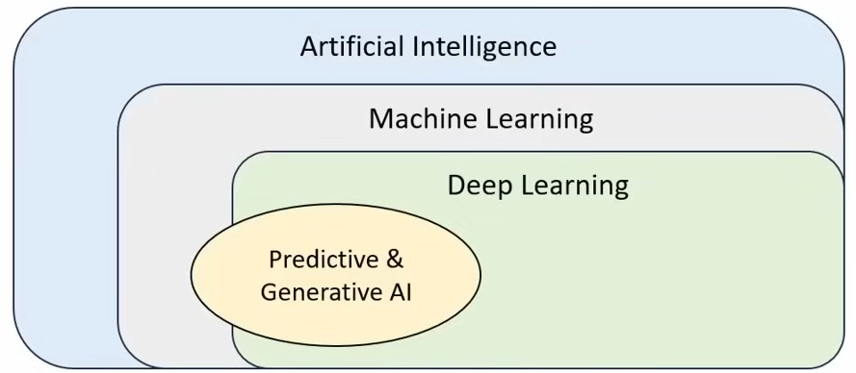

**Predictive & Generative AI**

* Predictive AI
  + Use machine learning to analyse historical data and predict trends
  + E.g. weather forecasting, security anomaly detection
* Generative AI
  + Use machine learning to learn patterns from existing data and create new content

**Predictive AI**

* Applications
  + Healthcare
  + Network security
  + Traffic management
  + Business forecasting
  + Weather forecasting
* Advantage
  + Improves decision-making by providing actionable insights
  + Detects potential problems before they occur
* Disadvantage
  + Requires high-quality, relevant historical data
  + Accuracy depends on how well the patterns in data generalize to new scenarios

**Generative AI**

* Applications
  + Text generation
  + Image generation
  + Video generation
* Advantage
  + Great for creative tasks where human input is limited/time-consuming
  + Enables automation of content creation across various fields
* Disadvantage
  + Risk of misuse (e.g. deepfakes)
  + Generated content is only as good as the quality of training material
  + Hallucinations (give wrong answers)

**Predictive & Generative AI in networking**

* Predicitve AI
  + Traffic Forecasting
  + Security threat detection
  + Predictive maintenance
* Generative AI
  + Network documentation
  + Config generation
  + Network design
  + Troubleshooting
  + Script generation

**AI in Cisco Catalyst Center**

* Cisco Catalyst Center (formerly DNA Center) features a variety of AI-enabled features to identify issues before they impact users, reduce the time required to solve issues, and increase the performance and security of the network
* Features include
  + AI Network Analytics
    - Use AI to establish baseline behaviour
    - Provides insights and recommendations for optimizing network performance
    - Continuously monitors the network to detect and predict anomalies
  + Machine Reasoning Engine
    - Use AI to find root cause of issue
    - Suggest methods to solve the issue / auto resolve issue
  + AI Endpoint Analytics
    - Identify and classify devices on network
    - Detects unauthorized devices / unusual behaviour
    - Simplifies onboarding by automating profiling and segmentation
  + AI-enhanced Radio Resource Management
    - Manage Access Points

## JSON, XML, YAML

Things covered

* Data serialization
* JSON (JavaScript Object Notation)
* XML (Extensible Markup Language)
* YAML (YAML Ain't Markup Language)

**Data Serialization**

* Process of converting data into a standardized format that can be stored (in a file) or transmitted (over network) and reconstructed later (i.e. by a different application)
  + Allows the data to be communicated btw applications in a way both applications understand
* Data serialization languages allow us to represent variables with text

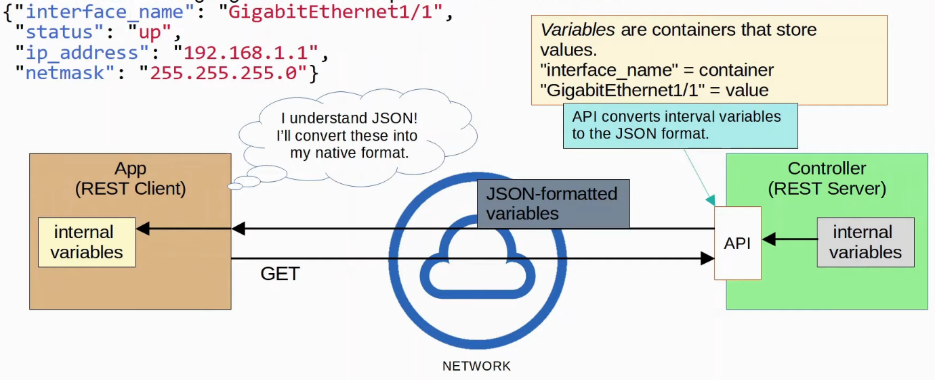

**JSON**

* An open standard file format and data interchange format that uses human-readable text to store and transmit data objects
* RFC 8259
* Whitespace insignificant
* 4 primitive data types
  + String
  + Number
  + Boolean: true/false, no quotes ("")
  + Null: null, no quotes
* 2 structured data types
  + Object/Dictionary: unordered list of key-value pair
  + Array: values don't have to be same types

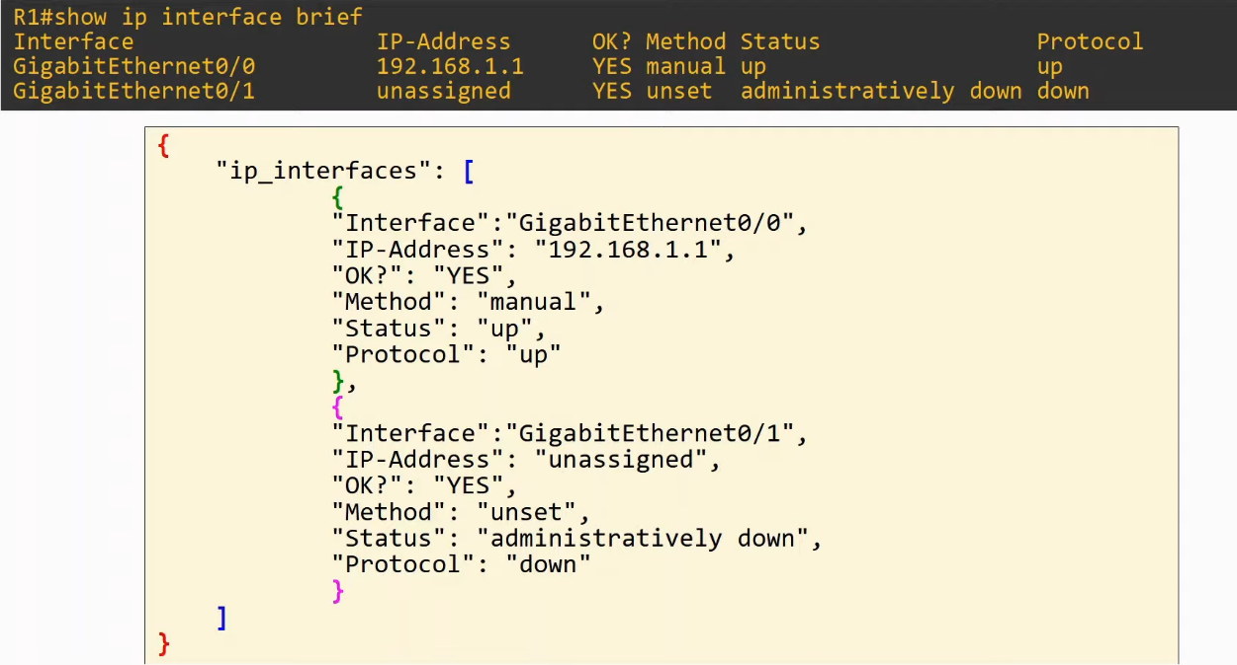

**XML**

* Developed as markup language, but now commonly used as data serialization language
  + Markup language (e.g. HTML) used to format text
* Whitespace insignificant
* Often used by REST APIs
* <key>value</key>

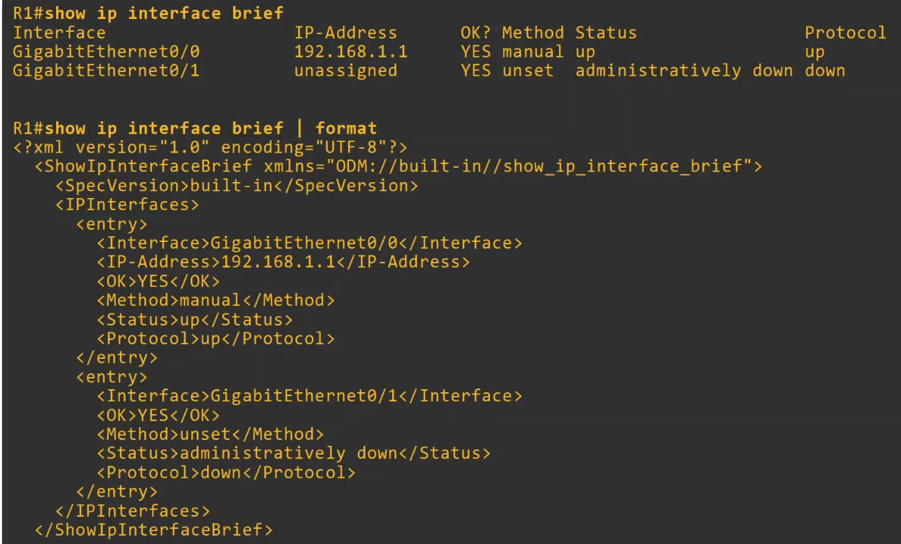

**YAML**

* Yet Another Markup Language, but to distinguish it as a data serialization language
  + YAML Ain't Markup Language
* Used by Ansible
* Human-readable
* Whitespace significant
* File starts with "---"
* "-" used to indicate a list
* Keys and values represented as
  + Key:value

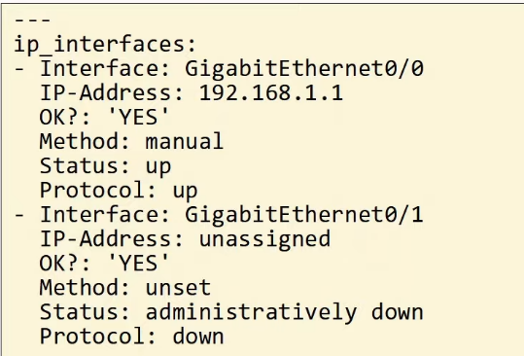

## REST APIs

Things covered

* API review
* CRUD operations and HTTP verbs
* REST APIs
* REST API Calls using Cisco DevNet

**API (Application Programming Interface)**

* Software interface that allows 2 applications to communicate
* Essential not just for automation, but for all application
* In SDN architecture, APIs used to communicate btw apps and the SDN controller (via NBI), and btw SDN controller and network devices (via SBI)
* NBI usually use REST APIs
* NETCONF and RESTCONF are popular southbound APIs

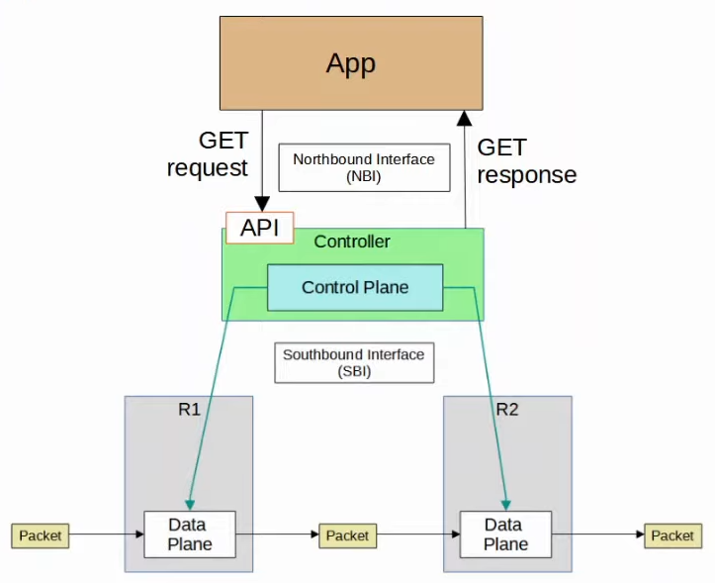

**CRUD**

* Create, Read, Update, Delete
* Operations performed using REST APIs
* HTTP uses verbs (aka methods) that map to these CRUD operations
* REST APIs typically use HTTP

**HTTP Verbs**

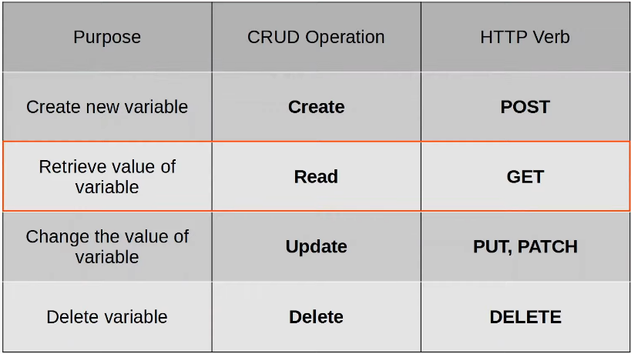

**HTTP Request**

* When a HTTP client sends a request to an HTTP server, the HTTP header includes information like this:
  + A HTTP Verb (e.g. GET)
  + An URI (Uniform Resource Identifier), indicating the resource it is trying to access

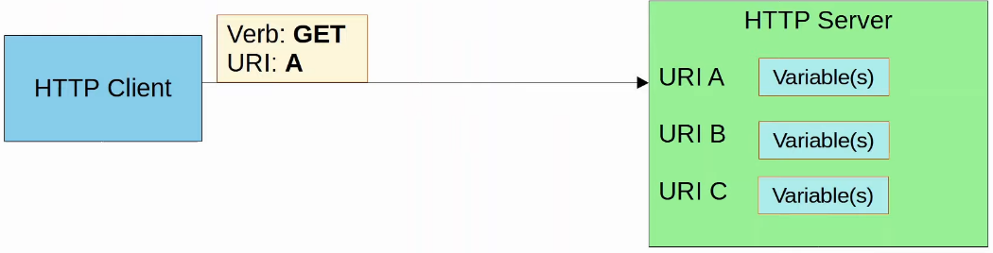

* Example URI



* The HTTP request can include additional headers which pass additional information to the server



* An example would be an Accept header, which informs the server about the type(s) of data that can be sent back to the client
  + E.g. Accept: application/json or Accept: application/xml
* When a REST client makes an API call (request) to a REST server, it will send a HTTP request like the one above
* Note:
  + *REST APIs don't have to use HTTP for communication, although HTTP is the most common choice
  + REST is a framework

**HTTP Response**

* Will include a status code indicating if the request succeeded or failed, as well as other details
* The first digit indicates the class of the response
  + 1xx informational : the request was received, continuing process
  + 2xx successful : the request was successfully received, understood, and accepted
  + 3xx redirection : further action needs to be taken in order to complete the request
  + 4xx client error: the request contains bad syntax or cannot be fulfilled
  + 5xx server error: the server failed to fulfil an apparently valid request

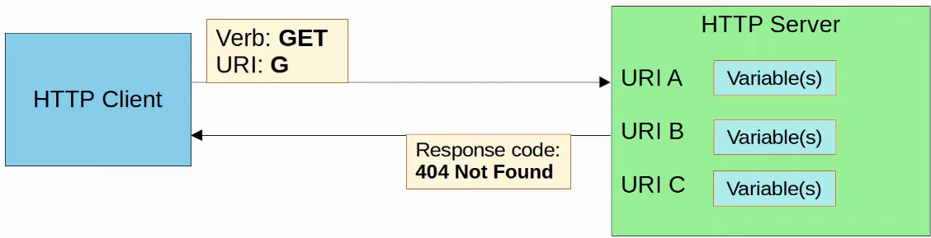

**Example**

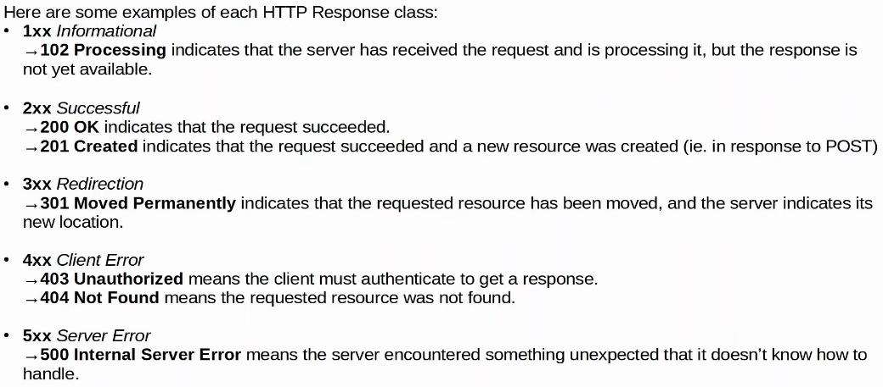

**REST (Representational State Transfer)**

* Aka REST-based APIs or RESTful APIs
* REST isn't a specific API, instead, it describes a set of rules about how the API should work
* The 6 constraints of RESTful architecture
  + Uniform interface
  + Client-server
  + Stateless
  + Cacheable or non-cacheable
  + Layered system
  + Code-on-demand (optional)
* For applications to communicate over a network, networking protocols must be used to facilitate those communications
  + For REST APIs, HTTP(S) is the most common choice
* **For CCNA**
  + CRUD
  + HTTP client request verbs
  + HTTP server response codes
  + Basic characteristics of REST APIs

**Client-Server**

* REST uses a client-server architecture
* The client uses API calls (HTTP Requests) to access the resources on the server
* The separation btw the client and server means they both change and evolve independently of each other
  + When client/server application changes, the interface btw them must not break

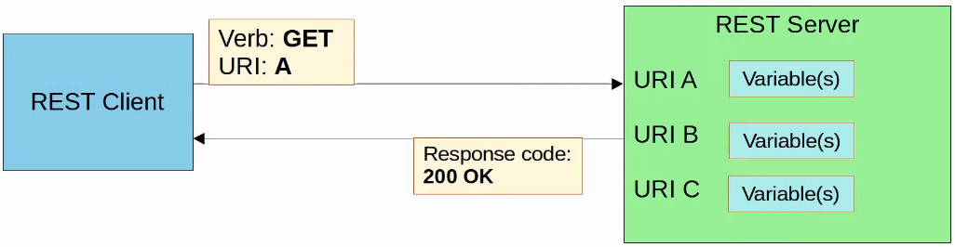

**Stateless**

* REST APIs exchanges are stateless
* This means that each API exchange is a separate event, independent of all past exchanges btw the client and server
  + The server does not store information about previous requests from the client to determine how it should respond to new requests
* If authentication is required, client must authenticate with the server for every request
* TCP is an example of stateful protocol
* UDP is an example of stateless protocol
* Note: *Although REST APIs use HTTP, which uses TCP (stateful) as its layer 4 protocol, HTTP and REST APIs themselves are not stateful
  + The functions of each layer (layer 4 and 7) are separate

**Cacheable / Non-cacheable**

* REST APIs must support caching of data
* Caching refers to storing data for future use
* Not all resources have to be cacheable, but cacheable resources MUST be declared as cacheable

**Cisco DevNet**

* Cisco application used for automation

**Day 61 (2) - REST API Authentication**

Things covered

* Authentication
* Authentication types

## REST API Authentication

* Authentication is the process of validating the identity of a user or system to ensure legitimate access to resources
  + For API, the resource is the application and its data
* W/o authentication, unauthorized users can send API requests, potentially accessing sensitive data or modifying the application
  + Implementing a reliable authentication method is essential for protecting applications and data
* Many APIs track usage for analytics and billing purposes
  + E.g. charging customers according to how much they use the API

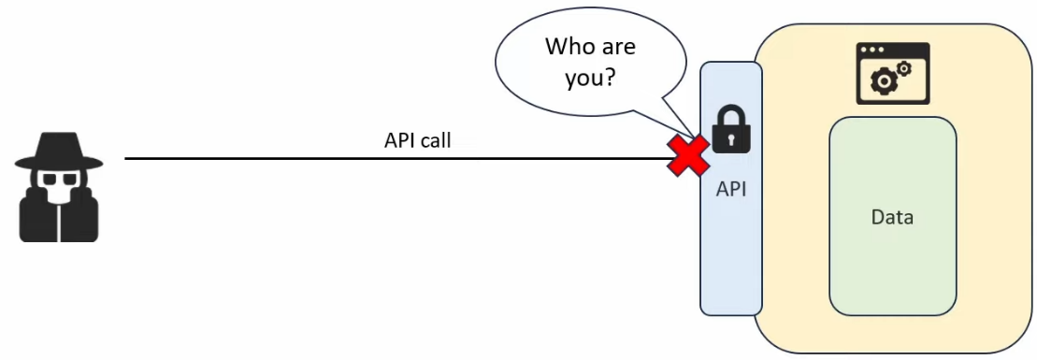

**Types of REST API authentication**

* Also called 'methods' or 'schemes'
* We will cover 4 types
  + Basic authentication
    - Sends a username and password in every request, encoded in Base64
  + Bearer authentication
    - Uses a token (bearer token) as an HTTP header in each of the request to verify the client's identity
  + API key authentication
    - Requires a unique key, typically included as a HTTP header, to authenticate API requests
  + OAuth2.0
    - A secure framework that grants access via access token, commonly used for delegated access and third-party authentication

**Basic Authentication**

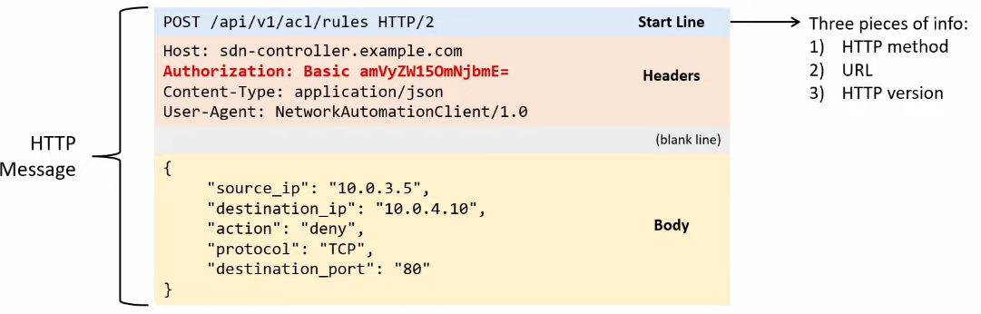

* Includes a username and password in the HTTP headers of each API request for authentication
* Credentials are encoded in Base64 format but not encrypted
  + Better to use HTTPS (TLS) for security
* Username/password are sent in the format "username:password", encoded in Base64

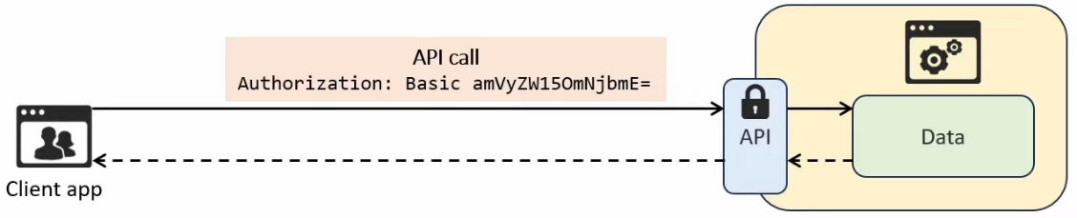

* Advantage
  + Simple and easy to implement
* Disadvantage
  + Since credentials are used in every request, attackers could steal them if the connection is not properly secured
  + Even if using HTTPS for encryption, relying solely on a username/password combination isn't particularly secure

**Bearer Authentication**

* Uses a token instead of username/password
  + A form of token-based authentication
* How it works
  + Client first obtain the token by authenticating with an authorization server
    - Could be done using Basic Authentication or another method
  + For each API call, the client includes the token in the HTTP Authorization header
    - E.g.



* 'Bearer': anyone who possess the token can use it
  + If an attacker steals the token, they can make API calls as if they were the legitimate user
  + To mitigate against this, tokens expire after a set period of time

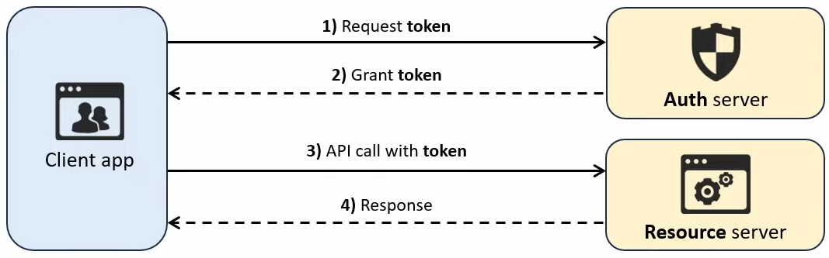

* Advantage
  + More secure than Basic Authentication (no need to transmit the username/password for every API call)
  + Tokens expire, so a stolen token will only be temporarily valid
* Disadvantage
  + If a token is stolen, the attacker can access the API until it expires
  + Tokens need to be refreshed periodically, adding extra complexity to implement
  + Should only be used with HTTPS

**API Key Authentication**

* Uses a static key issued by the API provider
  + Client uses this key in each API call for authentication
  + Key is static and remains valid until revoked
* API key can be sent in
  + HTTP Authorization header (recommended)
  + URL - not recommended since URL are often logged by web servers, browsers, etc
  + Cookie - sometimes used for web-based APIs

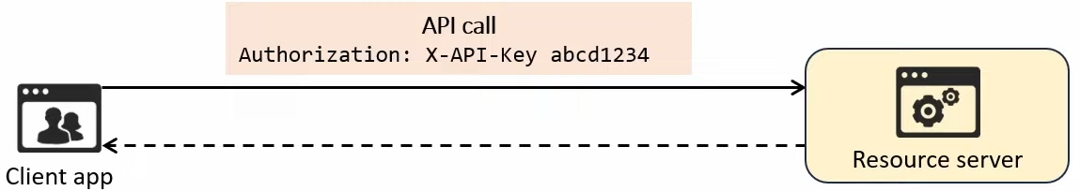

* Advantages
  + Easier to implement than Bearer authentication (no need to refresh tokens)
  + Good for tracking API usage, often used by cloud services and third-party APIs
* Disadvantage
  + If stolen, the key grants full access until revoked
  + API keys must be rotated manually to maintain security, whereas tokens expire automatically

**OAuth2.0**

* A secure authentication framework that is widely used in modern web applications
* Provides access delegation, granting third-party applications limited access to resources on behalf of the resource's owner
  + No need to share the resource owner's credentials with the third party
* Examples
  + Logging in with Google
    - Many websites and apps offer the option to log in using your Google account
  + Connecting apps to social media account
    - Many apps can be connected to accounts on social media platforms like Instagram and Facebook

* The authentication/authorization process consists of 6 steps
  1. Client app requests authorization from the resource owner (you) to access the resource (your Google calendar data)
  2. Resource owner grants authorization by logging into their account (e.g. Google) and giving permission
  3. Client app exchanges the authorization grant for an access token from the auth server
  4. Auth server provides an access token to the client app
  5. Client app sends the access token to the resource server (e.g. Google's server hosting calendar data) to request the resource
  6. Resource server validates the access token and provides the requested resource (calendar data) to the client app

* The access token granted in step 4 functions just like the token used in bearer authentication
  + Grants access to the specified resource within the appropriate scope of access (e.g. read-only access)
  + Access tokens expire after a short period, but Auth2.0 uses refresh tokens (granted by Auth server) to obtain new access token w/o requiring the user to login every time

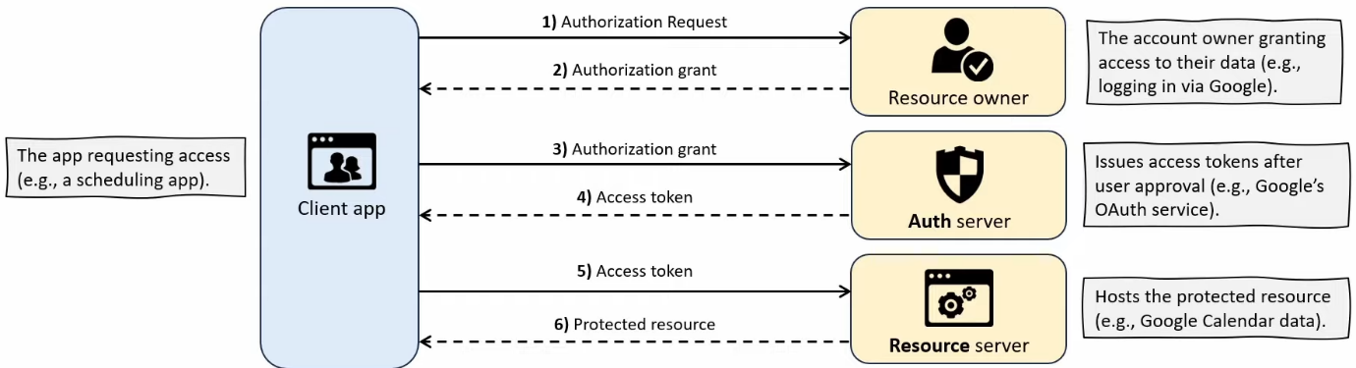

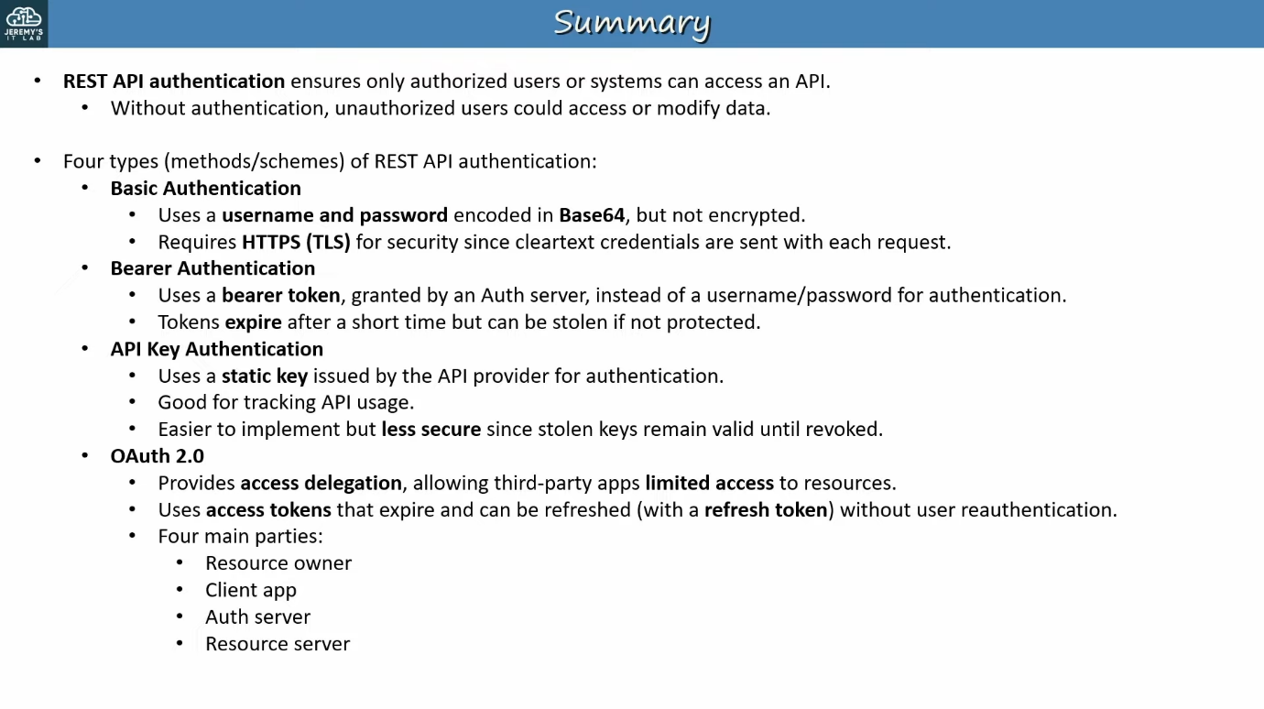

## Software Defined Networking

Things covered

* SDN Review
* Cisco SD-Access
* Cisco DNA Center
* DNA Center network management vs traditional

SDN Review

* Software-defined networking (SDN) is an approach that centralizes the control plane into an application called a controller
* Traditional control planes use a distributed architecture
* Controller can interact programmatically with network devices using APIs

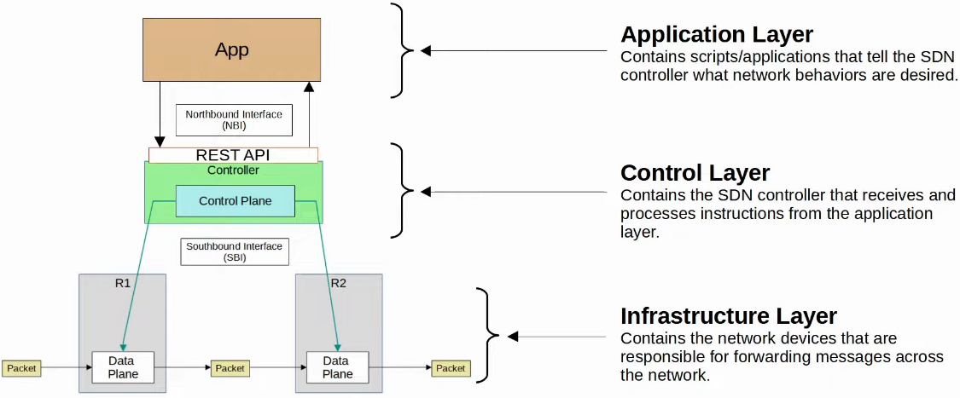

Cisco SD-Access

* This is Cisco's SDN solution for automating campus LANs
  + ACI (Application Centric Infrastructure) is their SDN solution for automating data center networks
  + SD-WAN is their SDN solution for automating WANs
* Cisco DNA (Digital Network Architecture) Center is the controller at the center of SD-Access

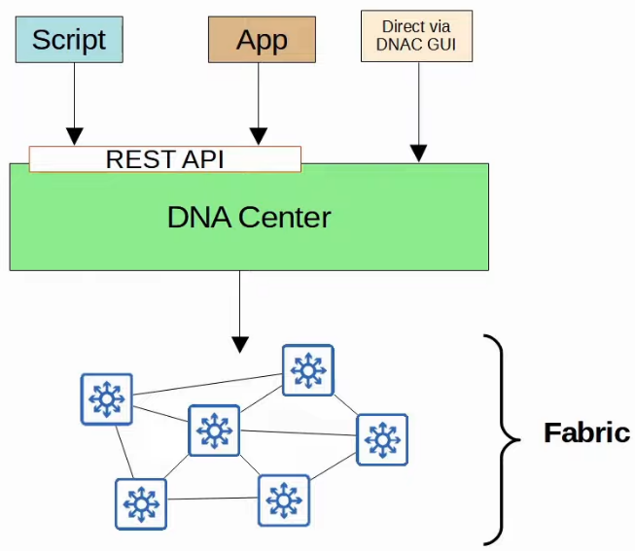

* Underlay
  + The underlying physical network of devices and connections (including wired and wireless) which provide IP connectivity (i.e. using IS-IS)
  + Multilayer switches and their connections
* Overlay
  + The virtual network built on top of the physical underlay network
  + SD-Access uses VXLAN (Virtual Extensible LAN) to build tunnels
* Fabric
  + Combination of the overlay and underlay
  + The physical and virtual network as a whole

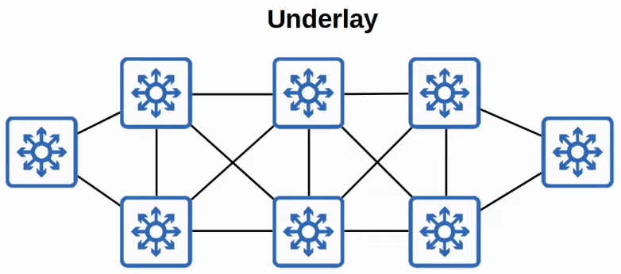

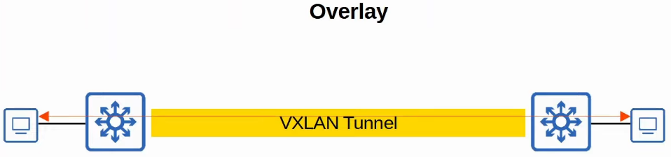

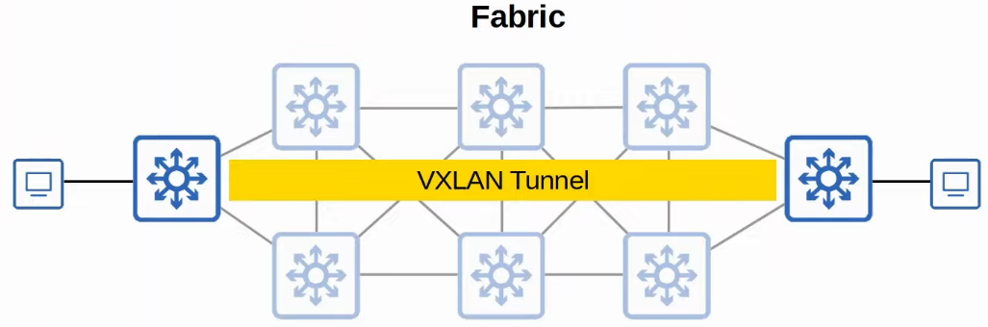

SD-Access Underlay

* Purpose is to support the VXLAN tunnels of the overlay
* There are 3 different roles for switches in SD-Access
  + Edge nodes
    - Connect to end hosts
  + Border nodes
    - Connect to devices outside of the SD-Access domain, i.e. WAN routers
  + Control nodes
    - Use LISP (Locater ID Separation Protocol) to perform various control plane functions
* You can add SD-Access on top of an existing network (brownfield deployment) if your network hardware and software supports it
  + In this case, DNA Center won't configure the underlay
* A new deployment (greenfield deployment) will be configured by DNA center to use the optimal SD-Access underlay
  + All switches are Layer 3 and use IS-IS as their routing protocol
  + All links btw switches are routed ports. This means STP is not needed
  + Edge nodes (access switches) act as the default gateway of end hosts (routed access layer)

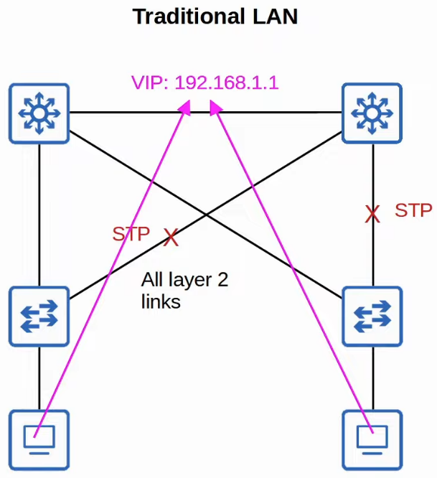

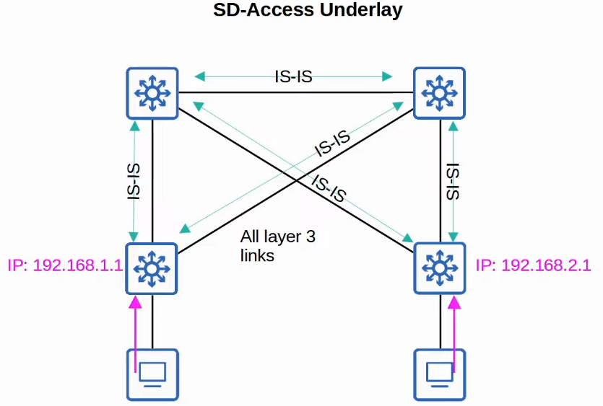

SD-Access Overlay

* LISP provides the control plane of SD-Access
  + A list of mappings of EID (endpoint identifiers) to RLOCs (routing locators) is kept
  + EIDs identify end hosts connected to edge switches, and RLOCs identify the edge switch which can be used to reach the end host
* Cisco TrustSec (CTS) provides policy control (QoS, security policy, etc)
* VXLAN provides the data plane of SD-Access

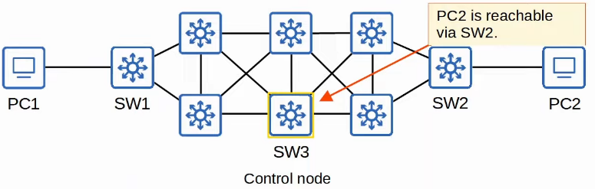

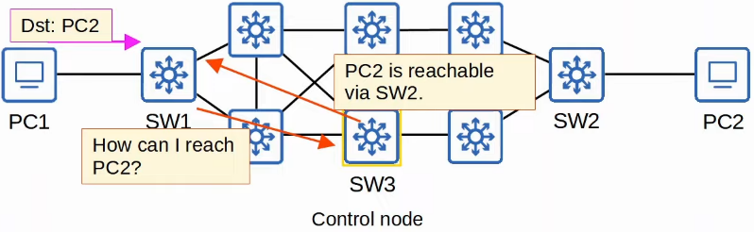

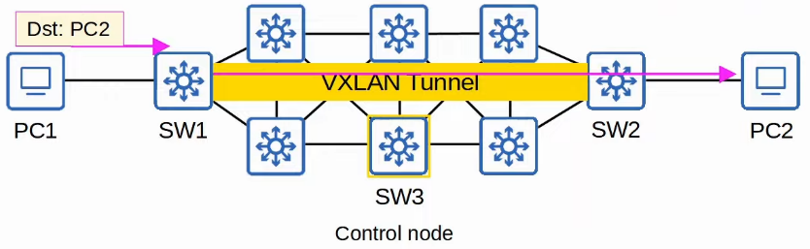

Cisco DNA Center

* Has 2 main roles
  + SDN controller in SD-Access
  + Network manager in a traditional network (non-SD-Access)
* DNA Center is an application installed on Cisco UCS server hardware
* It has a REST API which can be used to interact with DNA Center
* The SBI supports protocols such as NETCONF and RESTCONF (as well as traditional protocols like Telnet, SSH, SNMP)
* DNA Center enables Intent-Based Networking (IBN)
  + Allow the engineer to communicate their intent or network behaviour to DNA Center, and then DNA Center will take care of the details of the actual configurations and policies on devices
* Example of IBN
  + Traditional security policies using ACLs can become very cumbersome
    - ACLs have thousands of entries
    - The intent of entries is forgotten with time and as engineers leave and new engineers take over
    - Configuring and applying ACLs correctly across a network is cumbersome and leaves room for error
  + DNA Center allows the engineer to specify the intent of the policy (e.g. this group of users can't communicate with this group, this group can access this server but not that server), and DNA Center will take care of the details of implementing the policy

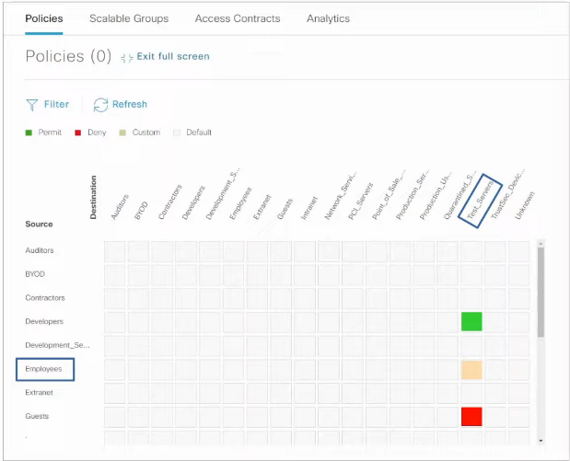

DNA Center vs Traditional Network Management

* Traditional network management
  + Devices configured 1-by-1 via SSH/console
  + Devices configured manually via console before being deployed
  + Configs and policies are managed per device (distributed)
  + New network deployments can take a long time due to manual labour required
  + Errors and failures are more likely due to increased manual effort
* DNA Center-based network management
  + Devices centrally managed and monitored from the DNA Center GUI or other applications using its REST API
  + Administrator communicates their intended network behaviour to DNA Center, which changes those intentions into configs on the managed devices
  + Configs and policies are centrally managed
  + Software versions are also centrally managed. DNA Center can monitor cloud servers for new versions and then update the managed devices
  + New network deployments are much quicker. New devices can automatically receive their configs from DNA Center w/o manual config

## Ansible, Puppet, Chef

Things covered

* Intro to configuration management tools
* Ansible
* Puppet
* Chef

Configuration Drift

* When individual changes made over time cause a device's config to deviate from the standard/correct configs as defined by the company
  + Most devices will have configs defined by standard templates by network architects
* Even without automation tools, best to have standard configuration management practices
  + E.g. when a change is made, save the config as text file and place it in a shared folder

Configuration Provisioning

* Refers to how configuration changes are applied to devices
  + Includes configuring new devices
* Traditionally done 1-by-1 via SSH
  + Not practical in large networks
* Configuration management tools like Ansible, Puppet and Chef allow us to make changes to devices on a mass scale with a fraction of the time/effort
* 2 essential components
  + Templates
  + Variables

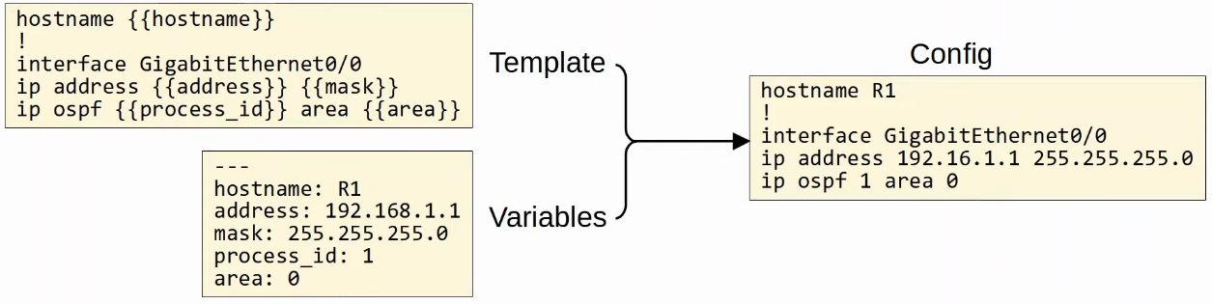

Configuration Management Tools

* They are network automation tools that facilitate the centralized control of large numbers of network devices
* E.g. Ansible, Puppet, Chef
  + Originally developed for VMs, to enable server system admins to automate the process of creating, configuring, and removing VMs
  + Also widely used to manage network devices
* Can perform tasks such as
  + Generate configs for new devices on a large scale
  + Perform config changes on devices (all device, or some devices)
  + Check device config for compliance with defined standards
  + Compare config btw devices, and btw different versions of configs on the same device

Ansible

* Config management tool owned by Red Hat
* Written in Python
* Agentless
  + Does not require any special software to run on managed device
* Use SSH to connect to devices, make config changes, extract information, etc
* Push model
  + Ansible server (Control node) uses SSH to connect to managed devices and push config changes to them
  + Puppet and Chef - Pull model
* After installing Ansible, must create several text files
  + Playbooks
    - 'Blueprints of automation tasks'
    - Outline the logic and actions of the tasks that Ansible should do
    - Written in YAML
  + Inventory
    - List the devices that will be managed by Ansible
    - List the characteristics of each device (e.g. device role - access switch, core switch, WAN router, firewall, etc)
    - Written in INI, YAML, etc
  + Templates
    - Represent a device's config file
    - Specific values for variables are not provided
    - Written in Jinja2
  + Variables
    - List the variables and their values
    - Values are substituted into the templates to create complete config files
    - Written in YAML

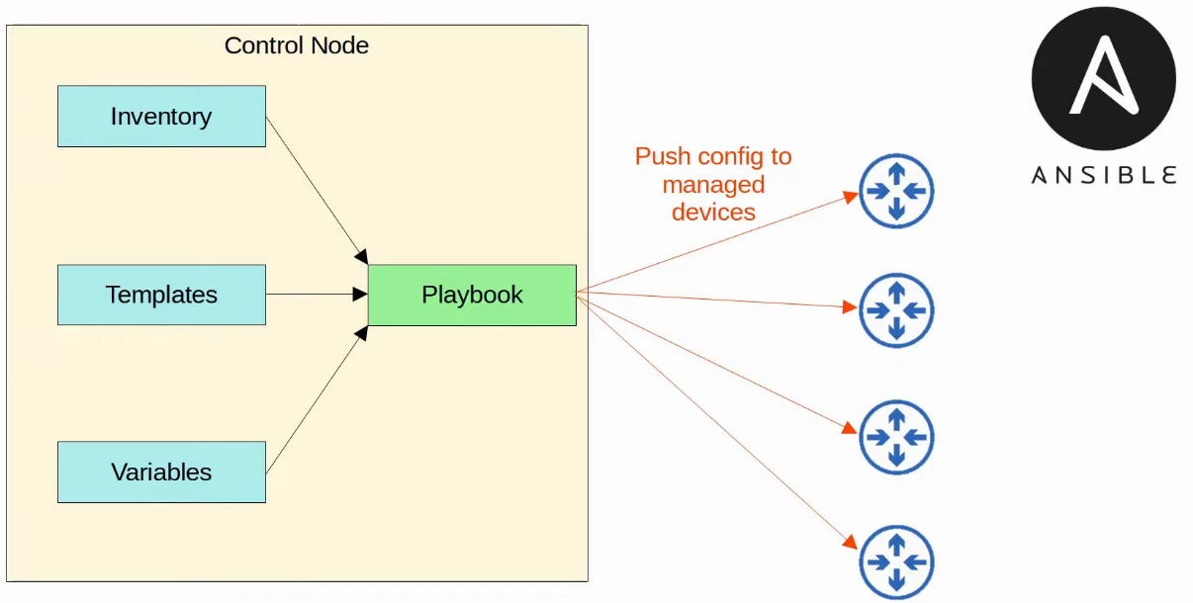

Puppet

* Written in Ruby
* Agent-based
  + Specific software must be installed on the managed device
  + Not all Cisco devices support a Puppet agent
* It can be run agentless
  + A proxy agent runs on an external hosts, and the proxy agent uses SSH to connect to the managed devices and communicate with them
* Puppet server called 'Puppet master'
* Pull model
  + Clients pull configuration from the Puppet master
  + Clients use TCP 8140
* Uses a proprietary language for files
* Text files required on the Puppet master
  + Manifest
    - Defines the desired config state of a network device
  + Templates
    - Similar to Ansible templates, used to generate manifests

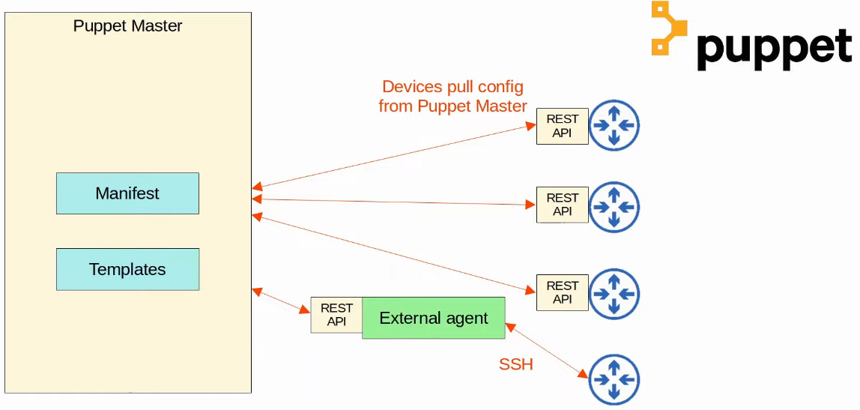

Chef

* Written in Ruby
* Agent-based
  + Specific software must be installed on managed devices
  + Not all Cisco device support a Chef agent
* TCP 10002
* Files use a DSL (Domain-specific Language) based on Ruby
* Text files used
  + Resources
    - 'Ingredients' in a recipe
    - Config objects managed by Chef
  + Recipes
    - 'Recipe' in a cookbook
    - Outline the logic and actions of the tasks performed on the resources
  + Cookbooks
    - A set of related recipes grouped together
  + Run-list
    - An ordered list of recipes that are run to bring a device to the desired config state

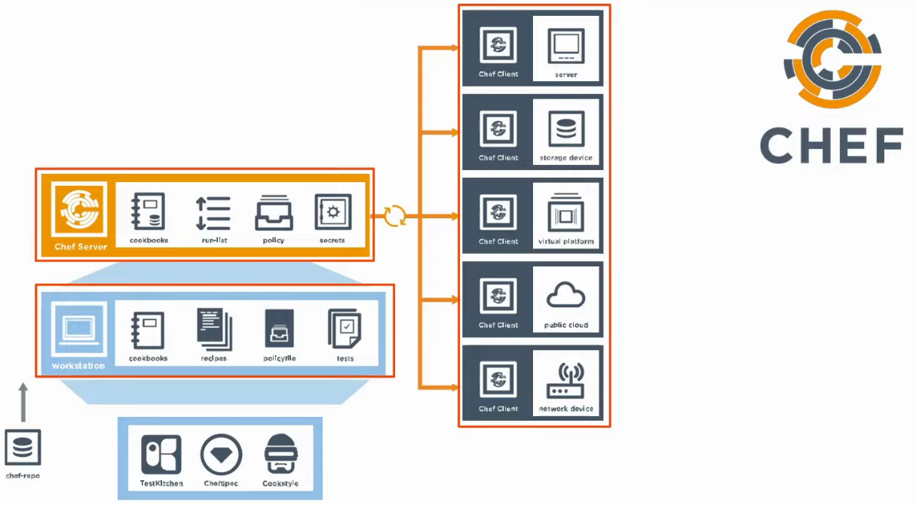

Comparison

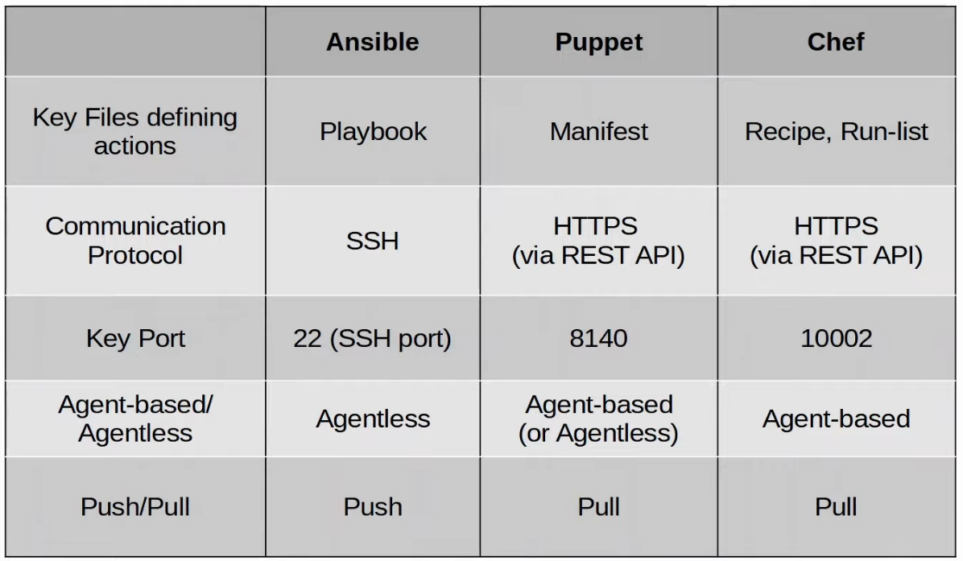

## Terraform

Things covered

* Infrastructure as Code
* Provisioning & Management
* Mutable/Immutable infrastructure
* Procedural vs Declarative
* Terraform Basics

Infrastructure as Code

* Practice of managing & provisioning infrastructure (e.g. servers, networks, clouds, etc) using machine-readable config files (code) instead of manual config (e.g. CLI/GUI)
* Ansible, Puppet, and Chef are examples of IaC configuration management tools
* Terraform
  + An IaC-based provisioning tool that automates the creation of infrastructure resources
* IaC automates infrastructure deployment and management, ensuring consistency, scalability, and repeatability

Provisioning Vs Management

* Config management (e.g. Ansible, Puppet, Chef)
  + Manages existing infrastructure by installing software, configuring settings, and maintaining system state
  + Ensures consistency by applying and enforcing configurations across multiple devices
* Infrastructure provisioning (e.g. Terraform)
  + Creates, modifies, and deletes infrastructure resources such as servers and network infrastructures
  + Focus on initial setup rather than ongoing configuration management
* Config management tools work on already existing systems
* Provisioning tools build infrastructure from scratch
* Terraform and Ansible can work together

Mutable vs Immutable Infrastructure

* Config management tools typically use a mutable infrastructure approach
  + Infra can be modified after deployment (e.g. applying updates, patches, or config changes)
  + Changes are made in place, meaning existing resources are updated rather than replaced

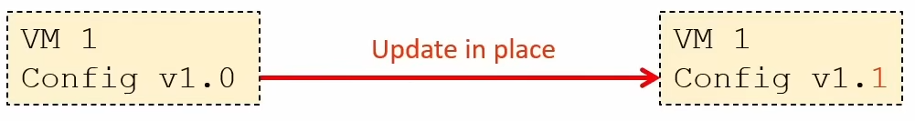

* Provisioning tools employ an immutable infra approach
  + Infra cannot be changed after deployment
    - "Changes" involve replacing the previous resource with a new version
  + No config drift, since each deployment starts from a fresh, predefined state

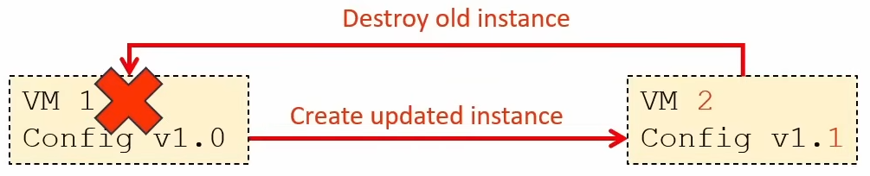

Procedural vs Declarative Approach

* Procedural approach (aka Imperative)
  + Follows explicit steps in a specific order to achieve the desired outcome
  + The user must define each action to config the infra
  + Provides greater control compared to a declarative approach

* Declarative approach
  + Defines the desired end state
  + The tool (e.g. Terraform) figures out the steps needed to achieve the goal
  + Easier to maintain and ensures consistency across deployments

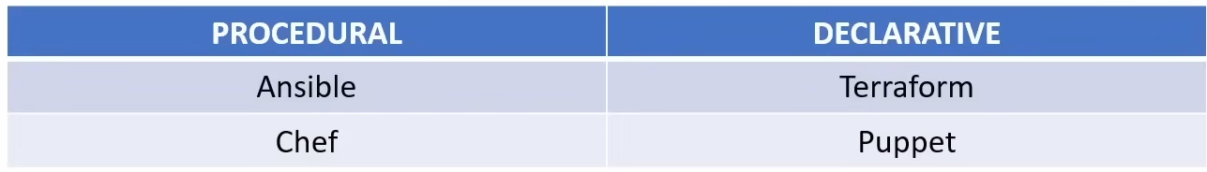

Terraform

* Open source IaC tool developed by HashiCorp
* Primarily a provisioning tool, focused on deploying infra resources on various cloud & on-prem platforms
  + These platforms are called providers
  + E.g. AWS, Azure, etc
  + Includes integrations with Cisco platforms like Catalyst Center, ACI, and IOS XE
* Push model, agentless
  + Does not require a software agent on infra it provisions or manages

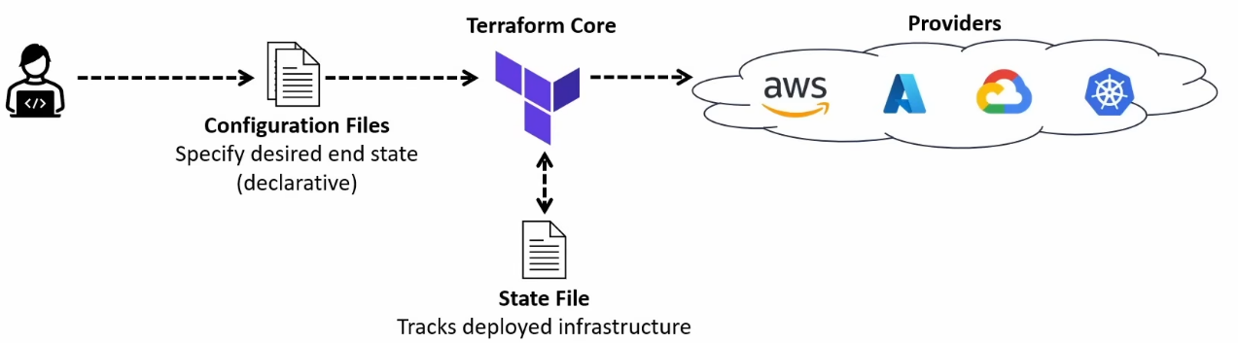

* The basic Terraform workflow consists of 3 main steps
  + Write
    - Define the desired state of your infra resources in config file
  + Plan
    - Verify the changes that will be executed before applying them
  + Apply
    - Execute the plan to provision and manage the infra resources
* Terraform core written in Go, config files written in HashiCorp Configuration Language (HCL)
  + HCL is a Domain Specific Language (DSL)
  + DSLs allow users to perform complex tasks with much less effort than a general language

